**Project team 9 - Mentor Management System**

### *Team Members: Matt O’Neill, Devika Unnikrishnan, Rakesh Gunti, Hussain Musthaq*

## ***PROJECT PROPOSAL***

**Content, Scope and Objectives**

The objective of this application is to create a communication between three parties. Party 1 is Admin, he maintains the list of all mentors and pupil. He takes care of all attendance and personal information of all people. Party 2 is a Mentor, he is assigned for one or more students. The mentor gives assignments to students and maintains a record of questions and answers. Party 3 is a Student, the student is assigned to one mentor. Given the attendance of the mentor in the system, students can approach the mentor on that day. Overall, both parties can communicate with admin for any information.

## ***PROJECT ENVIRONMENT***

OS: Windows / Mac

Database: MySQL Workbench 8.0.17

Front End: Bootstrap frontend framework

Middleware: NodeJs 10.x /Django 2.2

## ***HIGH LEVEL REQUIREMENTS***

### **Initial user roles**

|  |  |
| --- | --- |
| **User Role** | **Description** |
| Apprentice | Get and seek advice from a mentor |
| Mentor | Guide and assist apprentice in new career |
| Administrators | Has power to set up a mentor/apprentice relationship |

### **Initial user story descriptions**

Green - User story is completed

Cyan - so that statements were added as per suggestion.

Yellow - changed perspective of that user story or updated

Orange - new user story

|  |  |
| --- | --- |
| **Story ID** | **Story description** |
| 1 | As an apprentice, I want to send messages to a mentor |
| 2 | As a mentor, I want to send messages to an apprentice |
| 3 | ~~As a mentor, I want to post questions for the apprentice~~  As a mentor, I want to post a quiz for my apprentices so that i can test their learning.  Note: We assumed instead of posting one or more questions Mentor will post quiz which consists of one or more questions. |
| 4 | ~~As an apprentice, I want to respond to my mentor’s questions~~  As an apprentice I want to respond to the quiz posted by my mentor so that I can test my learning  Note: Instead of responding to all questions individually Apprentice will respond to one quiz. |
| 5 | As a mentor, I want to monitor the attendance of my apprentice at meetings so that i can add these details in the weekly report  Note: Just added “so that statement” to the user story. |
| 6 | ~~As an apprentice, I want to check in to meetings~~ |
| 7 | As a mentor, I want to post/update new homework so that apprentice can prepare for the quiz.  Note: Just added “so that statement” to the user story. |
| 8 | As an apprentice, I want to access homework assignments so that i can prepare for the quiz.  Note: Just added “so that statement” along with user story. |
| 9 | As a mentor, I want to file a weekly report on the apprentices so that I can track their progress.  Note: Just added “so that statement” to the user story. |
| 10 | As an apprentice, I want to Login/Logout to my account so that I can answer quiz and view appointment.  Note: Just added “so that statement” to the user story. |
| 11 | As an Administrator, I want to Create a relationship between mentor and apprentice. |
| 12 | As a mentor I want to schedule/cancel Appointments with my apprentices so that i can discuss their progress.  Note: We assumed only one person should schedule / cancel meeting that should be Mentor. Hence removed User story 6 and added this. |
| 13 | As a mentor, I want to Login/Logout to my account so that I can post quiz n schedule appointments  Note: This was implemented for all user roles, didn’t have user story to each user role. Hence added. |
| 14 | As an admin, I want to Login/Logout to my account, so that I can create mentor and apprentice relationship  Note: This was implemented for all user roles must didn’t have user story to each user role. Hence added. |

## ***HIGH LEVEL CONCEPTUAL DESIGN***

**Entities**:

Apprentice

Mentor

Administrator

Message

Quiz

~~Question~~ [ considered it to be multi-valued attribute of Quiz]

~~Answer~~ [ considered it to be multi-valued attribute of Quiz]

Homework

Appointment

Report

~~Attendance~~ [ considered it to be attribute of Appointment]

**Relationships**:

A mentor guides an Apprentice

Administrator assigns Apprentices to Mentors

Apprentice/Mentor/Administrator send/receives Messages

Mentor generates/files a Report

~~Apprentice schedules an Appointment~~ [user story is updated]

Mentor schedules / cancels Appointment

Mentor monitors / marks Attendance

~~Mentor posts Question~~ [user story is updated]

Mentor posts Quiz

~~Apprentice answers Mentor’s Questions~~ [user story is removed]

Apprentice responds / answers Quiz

***SPRINT-1***

**User Stories for Sprint 1:**

|  |  |
| --- | --- |
| **Story ID** | **Story description** |
| 11 | As an Administrator, I want to Create a relationship between mentor and apprentice. |
| 2 | As a mentor, I want to send messages to an apprentice |
| 1 | As an apprentice, I want to send messages to a mentor |

**CONCEPTUAL DESIGN:**

**Entities:**

Employee

Attributes:

Username

Password

Employee_Id

First_Name

Last_Name

Job_Title

Is_Admin

Mobile_Num [multi-valued]

Email [multi-valued]

Birth_Date

Join_Date

Address [multi-valued, composite]

Address_Line1

Address_Line2

City

State

Zip_Code

Note: We assumed that as these mentors, apprentices, admins are employees so create a base employee table then create respective tables for each user.

Apprentice

Attributes:

Apprentice_Id

Pref_ProgrammingLang

Pref_BackendFramework

Pref_FrontendFramework

Pref_DatabaseSystem

Mentor

Attributes:

Mentor_Id

Pref_ProgrammingLang

Pref_BackendFramework

Pref_FrontendFramework

Pref_DatabaseSystem

Administrator

Attributes:

Admin_Id

Message

Attributes:

Msg_Id

Sender_Id

Receiver_Id

Msg_Time

Msg_Text

**RELATIONSHIPS:**

Employee send/receive message

Cardinality: one-to-many

Participation:Employee has partial participation

Message has partial participation

Mentor coaches Apprentice

Cardinality: one-to-many

Participation: Mentor has partial participation

Apprentice has total participation

~~Apprentice has a Mentor~~

~~Cardinality: Many to One~~

~~Participation: Apprentice has total participation~~

~~Mentor has partial participation~~

Justification: It is the same as the 2nd relation in this relationships tab. Hence Ignoring/removing it.

**LOGICAL DESIGN:**

**Tables:**

Employee

Columns:

Employee_Id

Username

Password

First_Name

Last_Name

Job_Title

Birth_Date

Join_Date

Personal_Mobile_Num

Work_Mobile_Num

Personal_Email

Work_Email

Address

Columns:

Employee_Id [foreign key; references Employee_Id in Employee]

Address_Line1

Address_Line2

City

State

Zip_Code

Apprentice

Columns:

Apprentice_Id [foreign key; references Employee_Id in Employee]

Mentor_Id [foreign key; references Mentor_Id in Mentor]

Pref_ProgrammingLang

Pref_BackendFramework

Pref_FrontendFramework

Pref_DatabaseSystem

Mentor

Columns:

Mentor_Id [foreign key; references Employee_Id in Employee]

Pref_ProgrammingLang

Pref_BackendFramework

Pref_FrontendFramework

Pref_DatabaseSystem

Administrator

Columns:

Admin_Id [foreign key; references Employee_Id in Employee]

Message

Columns:

Msg_Id

Sender_Id [foreign key; references Employee_Id in Employee]

Receiver_Id [foreign key; references Employee_Id in Employee]

Msg_Time

Msg_Text

**IMPLEMENT & DEPLOY DATABASE**

Database name: MMS

**Sprint 1 - Key SQL Queries for Demonstration**

Query 1:

SELECT A.apprentice_id as apprentice_eid,concat(E.first_name,' ',E.last_name) as apprentice_name, A.mentor_id as mentor_eid, A.mentor_name FROM Employee as E, (SELECT A.apprentice_id, A.mentor_id, concat(E.first_name,' ',E.last_name) as mentor_name FROM Apprentice AS A, Employee E WHERE A.mentor_id = E.Employee_id) A WHERE A.apprentice_id = E.employee_id

Query 2:

SELECT A.apprentice_id AS apprentice_employee_id , M.receiver_id as receiver_employee_id, M.msg_text as message, M.Msg_time as message_time FROM Apprentice AS A, Message AS M WHERE M.sender_id = A.apprentice_id;

Query3:

SELECT A.admin_id AS Employee_Id, E.first_name, E.last_name, E.username, E.birth_date, E.join_date FROM Administrator AS A, Employee AS E WHERE A.admin_id = E.employee_id;

Query4:

SELECT E.employee_id, E.username,CONCAT(E.first_name,' ',E.last_name) AS employee_full_name,E.job_title,E.join_date, AD.address_line1, AD.address_line2, AD.city, AD.state, AD.zip_code FROM Employee AS E, Address AS AD WHERE E.employee_id = AD.employee_id;

**Demonstration:**

**Home Page:**

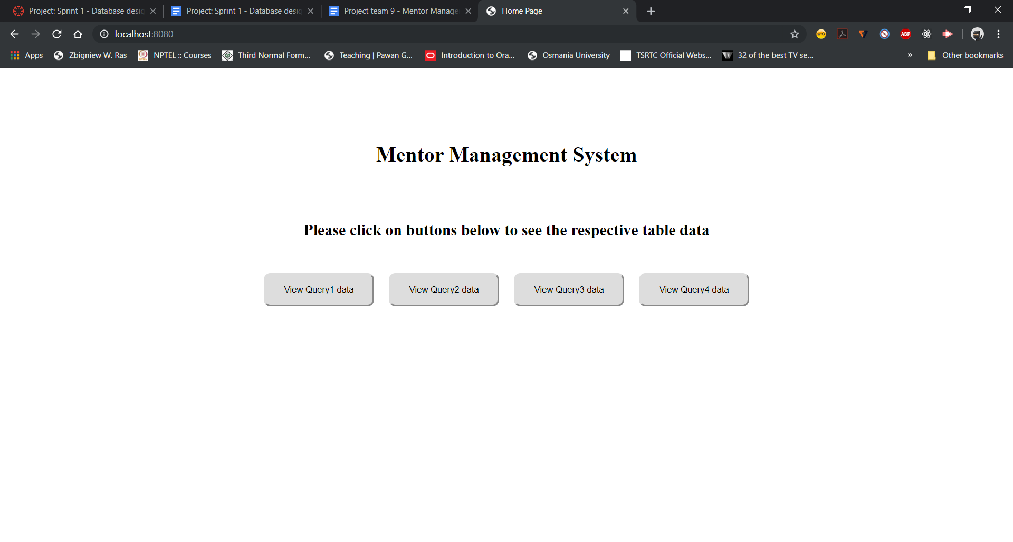

**Query1/Button1 Output:**

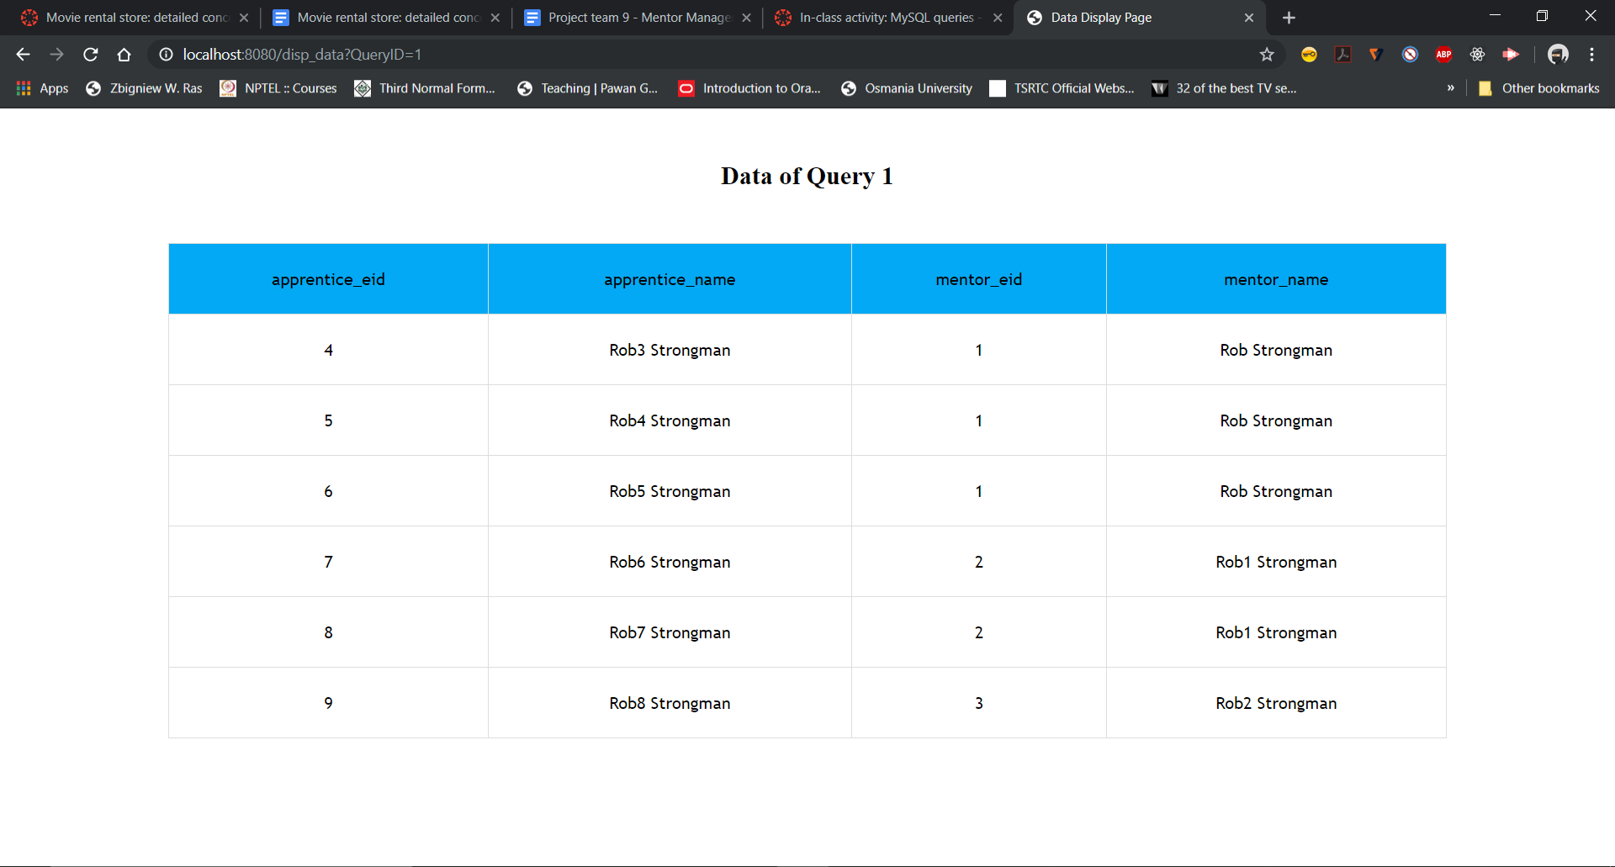

**Query2/ Button2 output:**

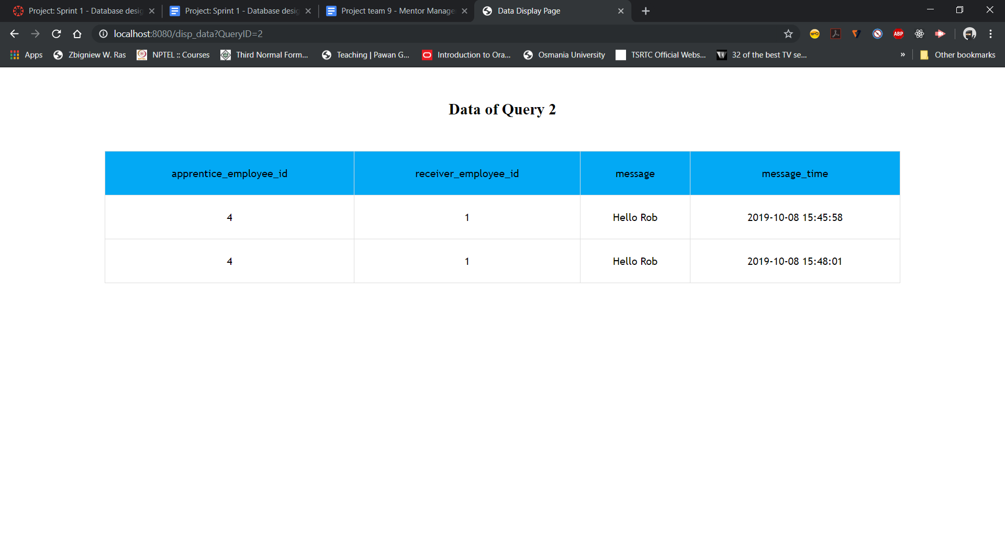

**Query3/ Button3 output:**

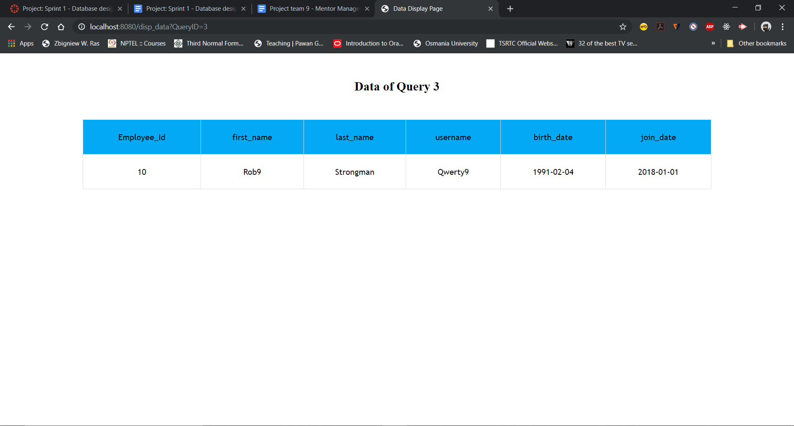

**Query4/ Button4 output:**

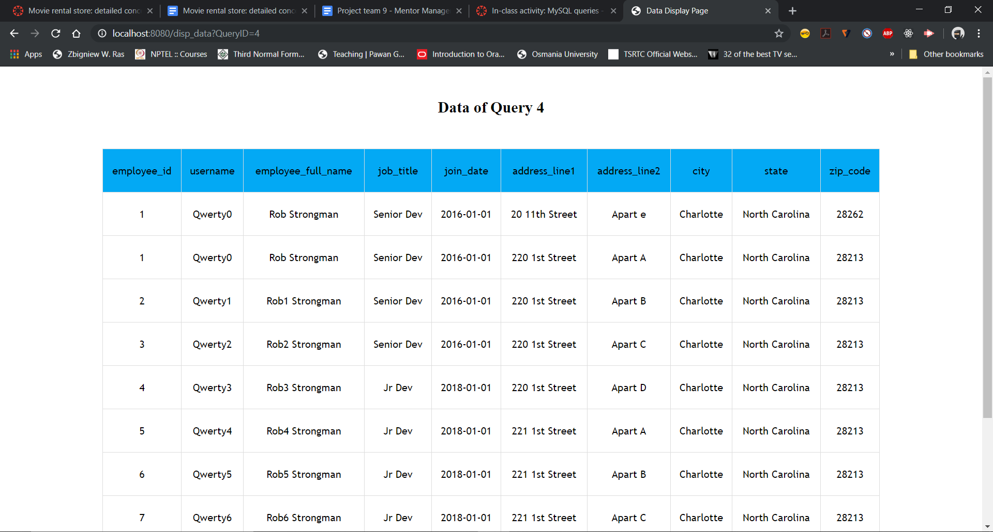

**SPRINT-2**

**User Stories for Sprint 2:**

|  |  |
| --- | --- |
| **Story ID** | **Story description** |
| 14 | As an admin, I want to Login/Logout to my account, so that I can create mentor and apprentice relationship |
| 13 | As a mentor, I want to Login/Logout to my account so that I can post quiz and schedule appointments. |
| 10 | As an apprentice, I want to Login/Logout to my account so that I can answer quiz and view appointments. |
| 12 | As a mentor I want to schedule/cancel Appointments with my apprentices so that i can discuss their progress. |
| 3 | As a mentor, I want to post a quiz for my apprentices so that i can test their learning. |
| 4 | As an apprentice I want to take the quiz posted by my mentor so that I can test my learning |
| 5 | As a mentor, I want to monitor the attendance of my apprentice at meetings so that i can add these details in the weekly report |

**CONCEPTUAL DESIGN:**

**Entities:**

Apprentice

Attributes:

Apprentice_Id

Pref_ProgrammingLang

Pref_BackendFramework

Pref_FrontendFramework

Pref_DatabaseSystem

Last_Login_Time

Last_Logout_Time

Is_Active

Mentor

Attributes:

Mentor_Id

Pref_ProgrammingLang

Pref_BackendFramework

Pref_FrontendFramework

Pref_DatabaseSystem

Last_Login_Time

Last_Logout_Time

Is_Active

Administrator

Attributes:

Admin_Id  
 Last_Login_Time

Last_Logout_Time

Is_Active

Appointment

Attributes:

Appointment_Id

Mentor_Id [foreign key Mentor_Id from Mentor]

Apprentice_Id [foreign key Apprentice_Id from Apprentice]

Start_Time

End_Time

Location(composite)

Building_Name

Floor_No

Room_No

Pre_Meeting_Notes

Post_Meeting_Notes

Status

Attended

Note:

Status will have only 4 values

“Scheduled” - Meeting is yet to happen,

“Done” - Meeting is completed by mentor and Apprentice,

“Cancelled” - Mentor Cancelled Meeting,

“InComplete” - Apprentice doesn’t show up to the meeting.

Attended Attribute is part of Story ID 5 why we did that is because we assumed that there are no other properties for attendance

Quiz:

Attributes:

Quiz_Id

Quiz_Name

Is_Active

Author

Questions[multi-valued, composite]

Question_text

Question_Id

Choice[multi-valued, composite]

Choice

Is_Right

Response [multi-valued, composite]

Response_Id

Res_Time

Attempt_No

Responder_Id [foreign key apprentice_id from apprentice]

Response_Answer[multi-valued, composite]

Answer_Id

Answer

Is_Right

**RELATIONSHIPS:**

Mentor schedules/cancels Appointment

Cardinality: one-to-many

Participation:Mentor has partial participation

Meeting has total participation

Mentor posts Quiz

Cardinality: one-to-many

Participation: Mentor has partial participation

Quiz has total participation

Apprentice responds / answers Quiz

Cardinality: Many to Many

Participation: Apprentice has partial participation

Quiz has partial participation

**LOGICAL DESIGN:**

Tables:

Apprentice

Columns:

Apprentice_Id [foreign key; references Employee_Id in Employee]

Mentor_Id [foreign key; references Mentor_Id in Mentor]

Pref_ProgrammingLang

Pref_BackendFramework

Pref_FrontendFramework

Pref_DatabaseSystem

Last_Login_time

Last_Logout_time

Is_Active

Justification for change: The login and logout time tracks account active status. If the given user has not logged in 90 days, their profile will be inactive.

Mentor

Columns:

Mentor_Id [foreign key; references Employee_Id in Employee]

Pref_ProgrammingLang

Pref_BackendFramework

Pref_FrontendFramework

Pref_DatabaseSystem

Last_Login_time

Last_Logout_time

Is_Active

Justification for change: The login and logout time tracks account active status. If the given user has not logged in 90 days, their profile will be inactive.

Administrator

Columns:

Admin_Id [foreign key; references Employee_Id in Employee]

Last_Login_time

Last_Logout_time

Is_Active

Justification for change: The login and logout time tracks account active status. If the given user has not logged in 90 days, their profile will be inactive.

Appointment

Columns:

Appointment_Id

Mentor_Id [foreign key; references Mentor_Id from Mentor Table]

Apprentice_Id [foreign key; references Apprentice_Id from Apprentice Table]

Start_Time

End_Time

Building_Name

Floor_No

Room_No

Pre_Meeting_Notes

Post_Meeting_Notes

Status

Attended

Quiz

Columns:

Quiz_Id

Quiz_Name

Is_Active

Author [foreign key; references Mentor_Id in Mentor]

Question

Columns:

Question_Id

Question_text

Quiz_Id [foreign key; references Quiz_Id in Quiz]

Choices

Columns:

Choice

Question_Id[foreign key; references Question_Id from Question]

Quiz_Id [foreign key; references Quiz_Id in Quiz]

Is_Right

Response

Columns:

Attempt_No

Quiz_Id [foreign key; references Quiz_Id in Quiz]

Responder_Id [foreign key; references Apprentice_Id from Apprentice]

Res_time

Response_Id

Response_Answer

Columns:

Answer_id

Answer

Is_Right

Question_Id [foreign key; references Question_Id from Question]

Response_Id [foreign key; references Response_Id in Response]

**NORMALIZATION:**

Tables:

Address

Normalized form: 4NF

Administrator

Normalized form: 4NF

Appointment

Normalized form: 4NF

Apprentice

Normalized form: 4NF

Choices

Normalization form:4NF

Employee

Normalized form: 1NF

Justification: Because all other attributes for an employee entry are also functionally dependent on the username field, this table is in 2NF. We think this is justified because unique usernames are important for a simple login system.

Mentor

Normalized form: 4NF

Message

Normalized form: 4NF

Question

Normalized form:4NF

Quiz

Normalized form:4NF

Response

Normalized form:4NF

Response_Answer

Normalized form: 4NF

**IMPLEMENT & DEPLOY DATABASE:**

Database Name: MMS_Sprint2

**Sprint2 - Key SQL Queries for Demonstration**

US - User story

us-14:

select E.employee_id, concat_ws(' ',E.first_name, E.last_name) Admin_FullName, E.username, E.Password, A.last_login_time, A.last_logout_time, IF(A.is_active, 'Active', 'Inactive') Account_status from Employee as E inner join Administrator as A on E.employee_id = A.admin_id

us-13:

select E.employee_id, concat_ws(' ',E.first_name, E.last_name) Mentor_FullName, E.username, E.Password, M.last_login_time, M.last_logout_time, IF(M.is_active, 'Active', 'Inactive') Account_status from Employee as E inner join Mentor as M on E.employee_id = M.mentor_id

us-10:

select E.employee_id, concat_ws(' ',E.first_name, E.last_name) Apprentice_FullName, E.username, E.Password, A.last_login_time, A.last_logout_time, IF(A.is_active, 'Active', 'Inactive') Account_status from Employee as E inner join Apprentice as A on E.employee_id = A.apprentice_id

us-12:

SELECT concat_ws(' ',E1.first_name,E1.last_name) Apprentice_Name, J.* FROM (SELECT A.apprentice_id, A.mentor_id, concat_ws(' ',E.first_name,E.last_name) Mentor_Name, A.start_time, A.end_time, A.status, A.pre_meeting_notes, IFNULL(A.post_meeting_notes, 'Nothing provided by Mentor') post_meeting_notes, concat_ws(', ', concat('Room No: ',A.room_no), concat('Floor No: ',A.floor_no), concat('Building: ',A.building_name)) Location FROM Appointment as A INNER JOIN Employee as E on E.employee_id = A.mentor_id) as J INNER JOIN Employee as E1 ON E1.employee_id = J.apprentice_id

us-3:

SELECT Q.quiz_id, Q.quiz_name, Q.is_active, Q.author, Qs.question_id, Qs.question_text, C.choice, C.is_right from Quiz as Q, Question as Qs, Choices as C WHERE Q.quiz_id = Qs.quiz_id AND Qs.Question_id = C.Question_id AND C.quiz_id = Q.quiz_id

us-4:

SELECT R.attempt_no,R.res_time, Q.quiz_id, Q.quiz_name, Qs.question_id, Qs.question_text, RA.is_right, RA.answer, R.Responder_id FROM Quiz as Q, Response as R, Question as Qs, Response_Answer as RA WHERE R.quiz_id = Q.quiz_id and Q.quiz_id = Qs.quiz_id and RA.response_id = R.response_id and Qs.question_id = RA.question_id ORDER BY R.Responder_id, Attempt_no

us-5:

SELECT concat_ws(' ',E1.first_name,E1.last_name) Apprentice_Name, J.* FROM (SELECT A.apprentice_id, A.mentor_id, concat_ws(' ',E.first_name,E.last_name) Mentor_Name, A.start_time, A.end_time, A.status, IF(A.attended, 'Yes', 'No') Attended, A.pre_meeting_notes,IFNULL(A.post_meeting_notes, 'Nothing provided by Mentor') post_meeting_notes, concat_ws(', ', concat('Room No: ',A.room_no), concat('Floor No: ',A.floor_no), concat('Building: ',A.building_name)) Location FROM Appointment as A INNER JOIN Employee as E on E.employee_id = A.mentor_id) as J INNER JOIN Employee as E1 ON E1.employee_id = J.apprentice_id

Merge of US-4 & US-5:

SELECT R.attempt_no,R.res_time, Q.quiz_id, Q.quiz_name, Qs.question_id, Qs.question_text, RA.answer, R.responder_id , C.choice FROM Quiz as Q, Response as R, Question as Qs, Response_Answer as RA , (SELECT * FROM Choices WHERE is_right = True) as C WHERE R.quiz_id = Q.quiz_id and Q.quiz_id = Qs.quiz_id and RA.response_id = R.response_id and Qs.question_id = RA.question_id and C.question_id = Qs.Question_id and C.quiz_id = Qs.quiz_id ORDER BY R.Responder_id

**Demonstration:**

Home Page

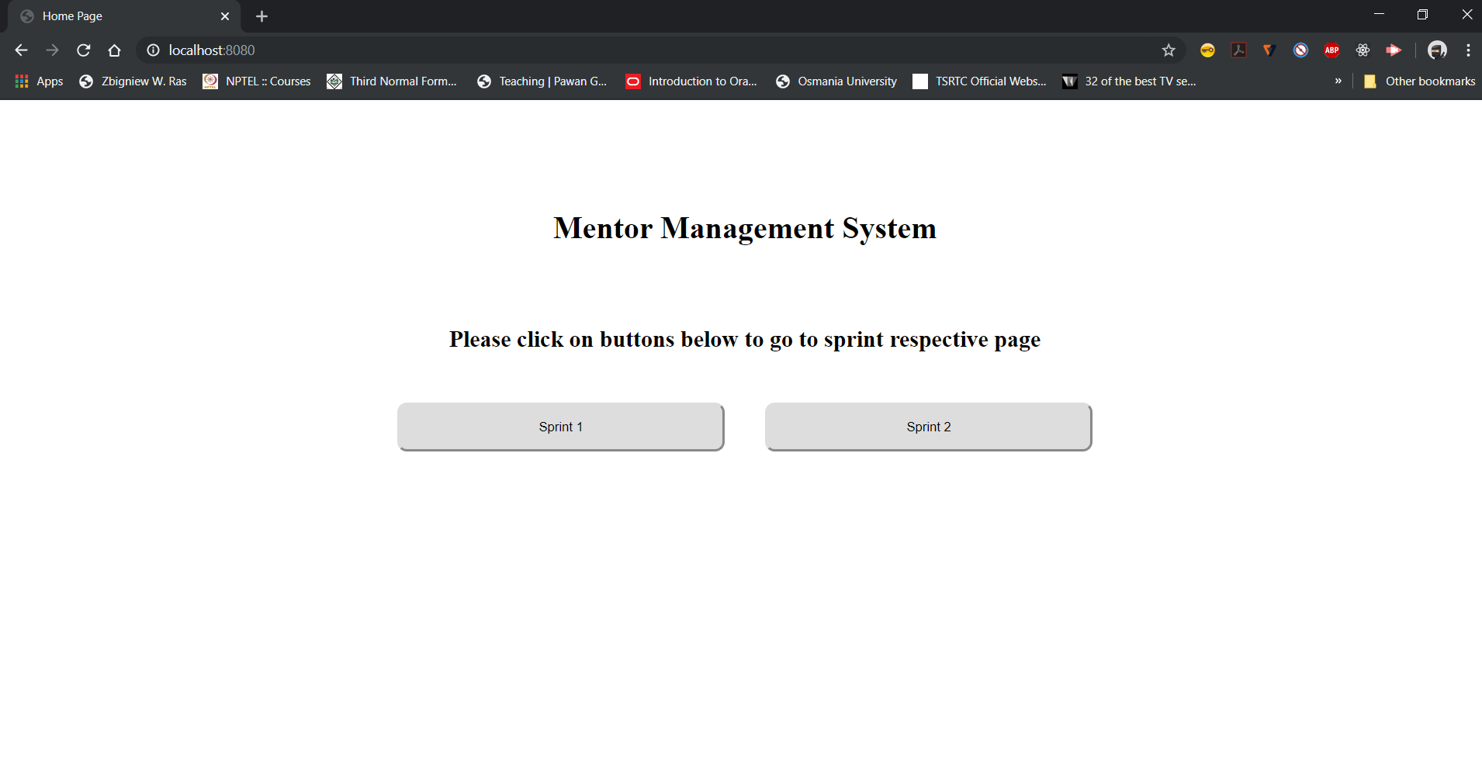

Current Sprint Page:

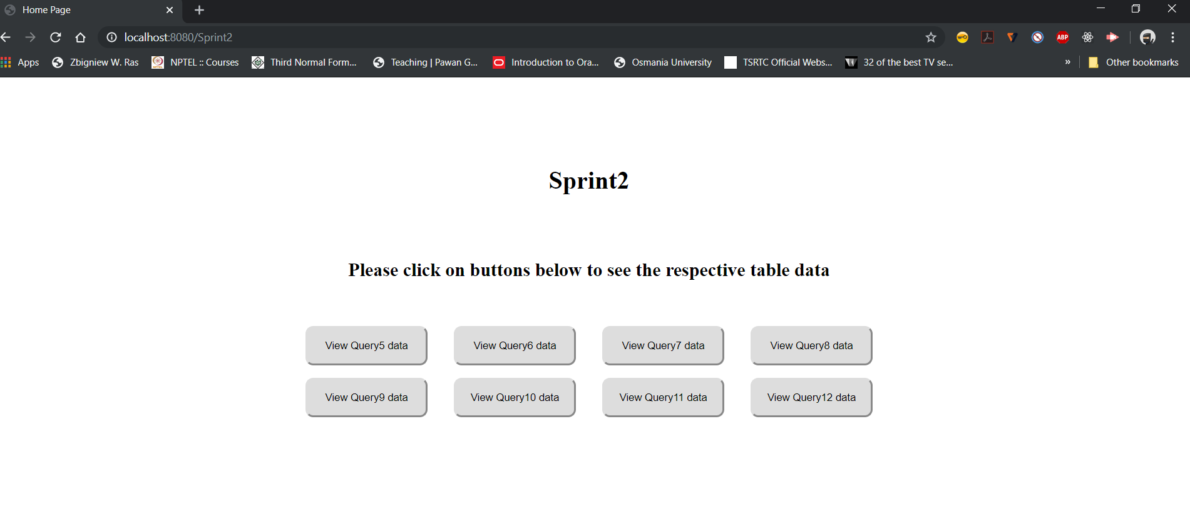

User story- 14:

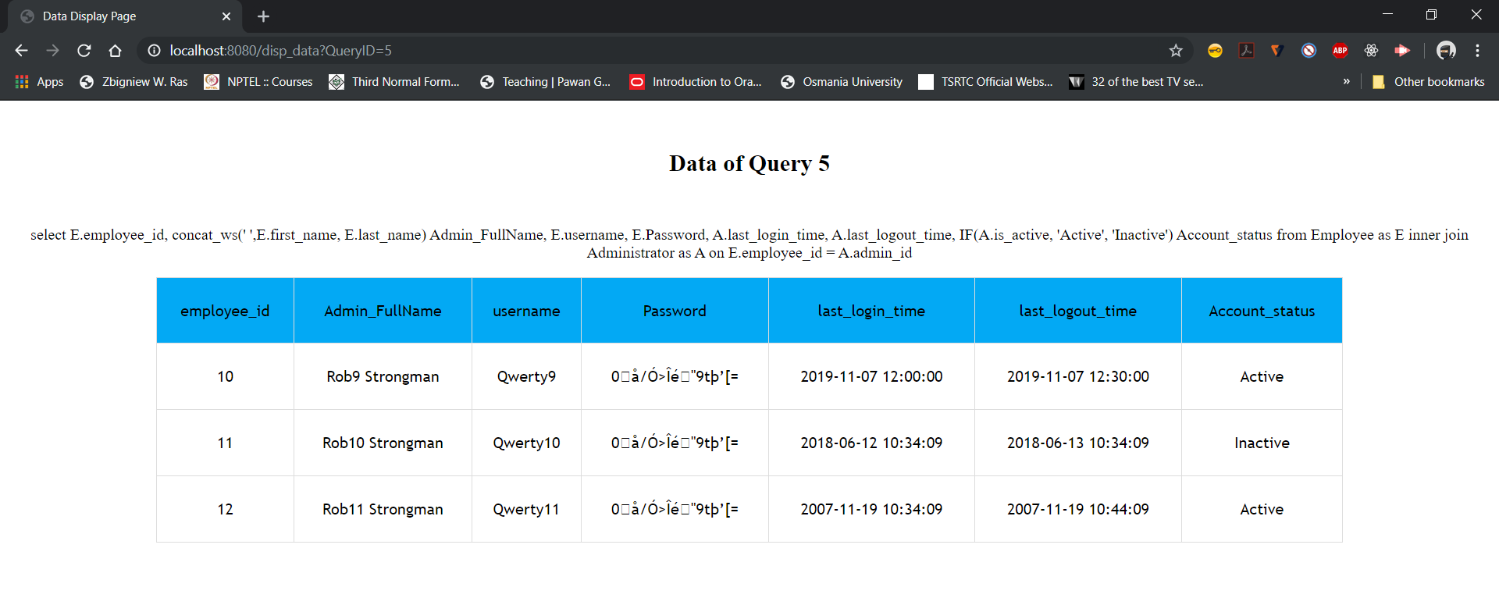

User story-13:

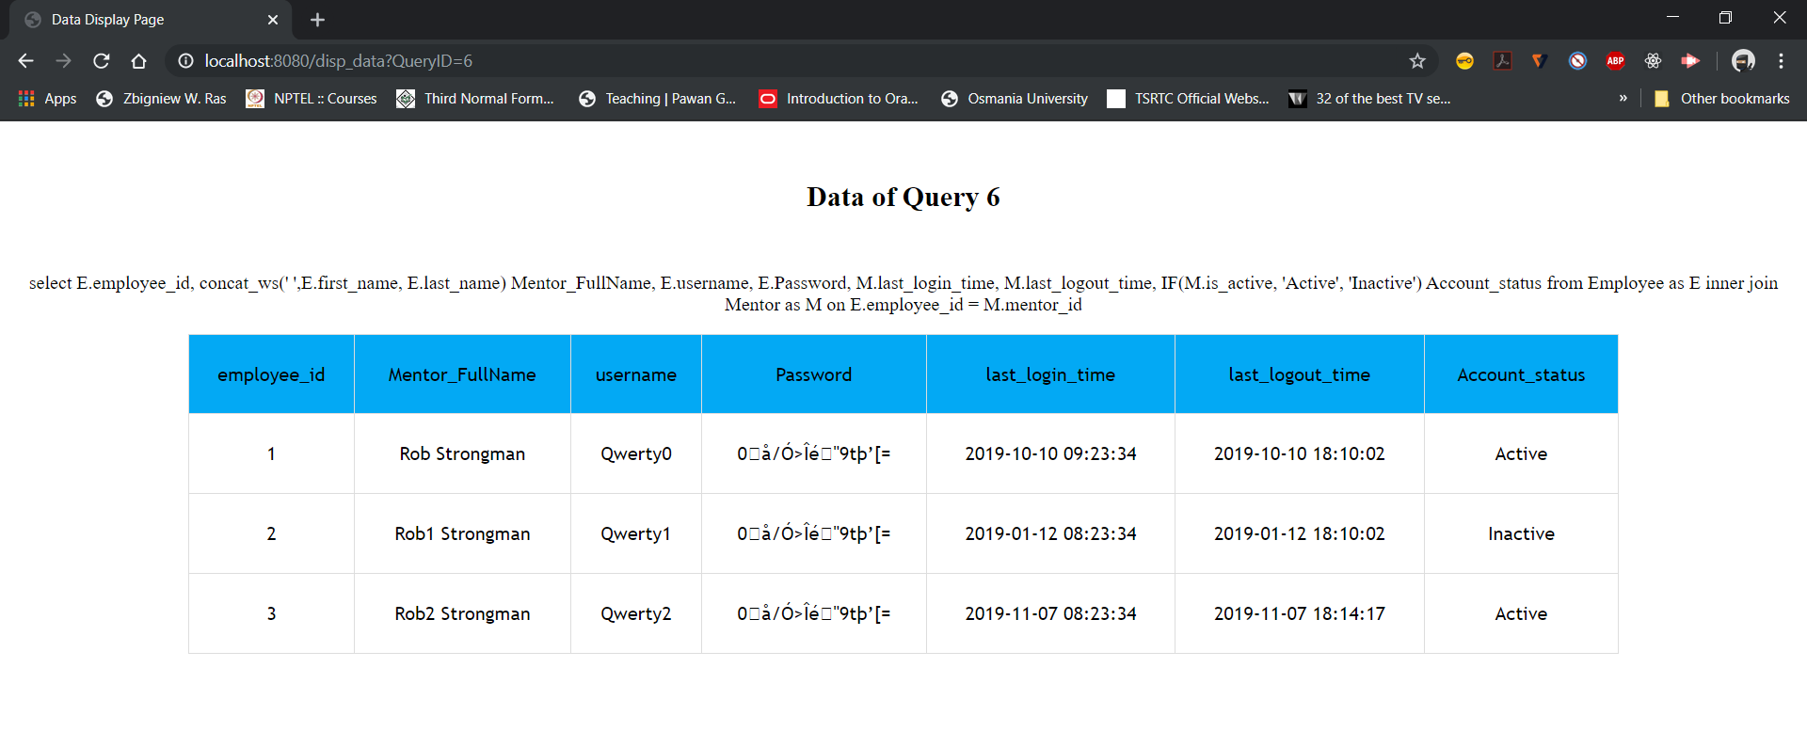

User story - 10:

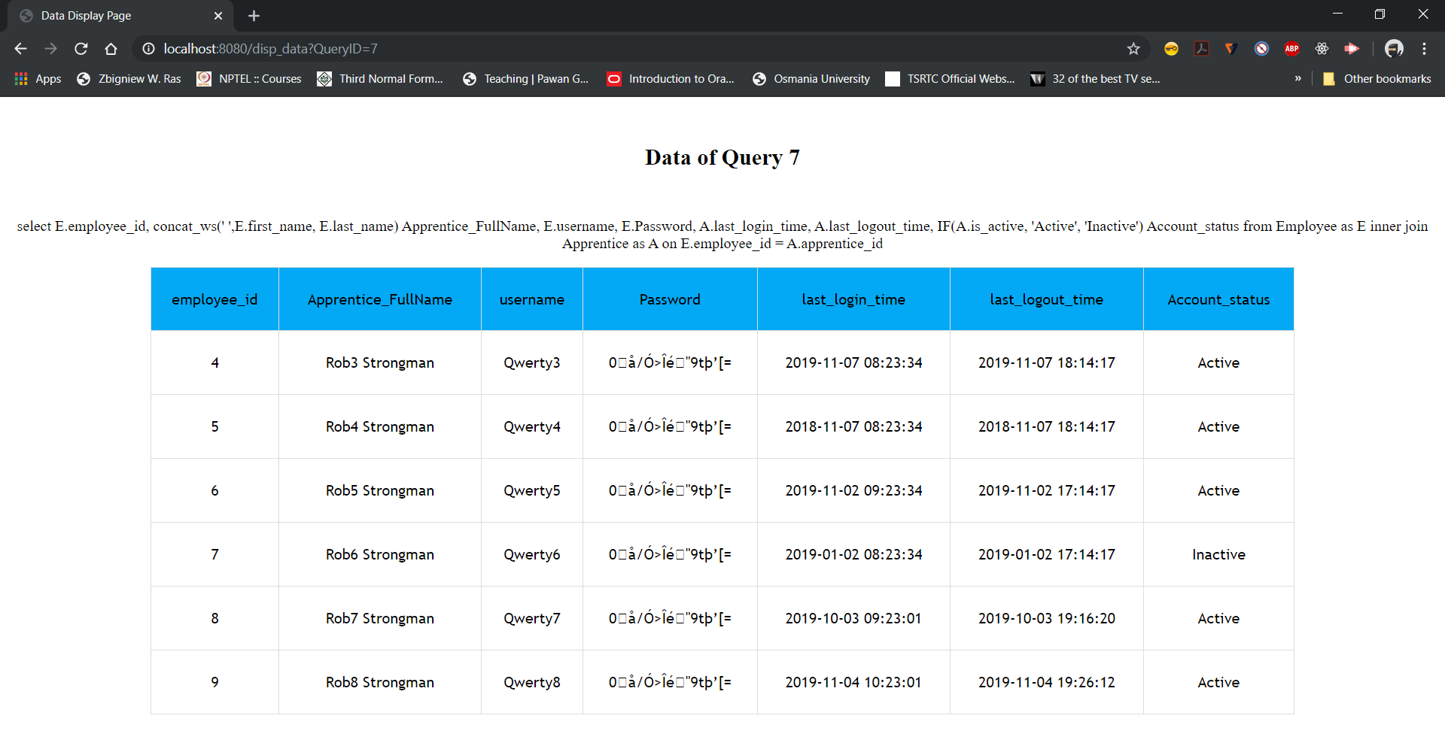

User story - 12:

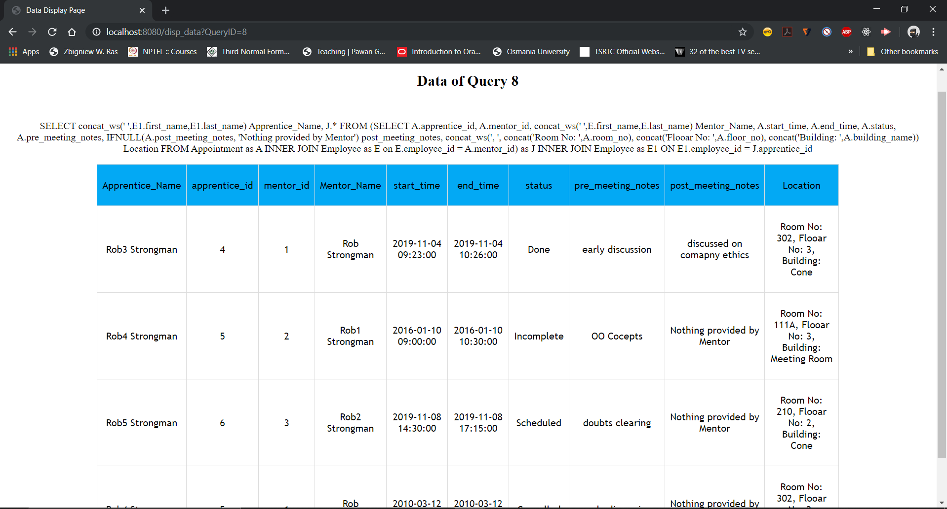

User story - 3:

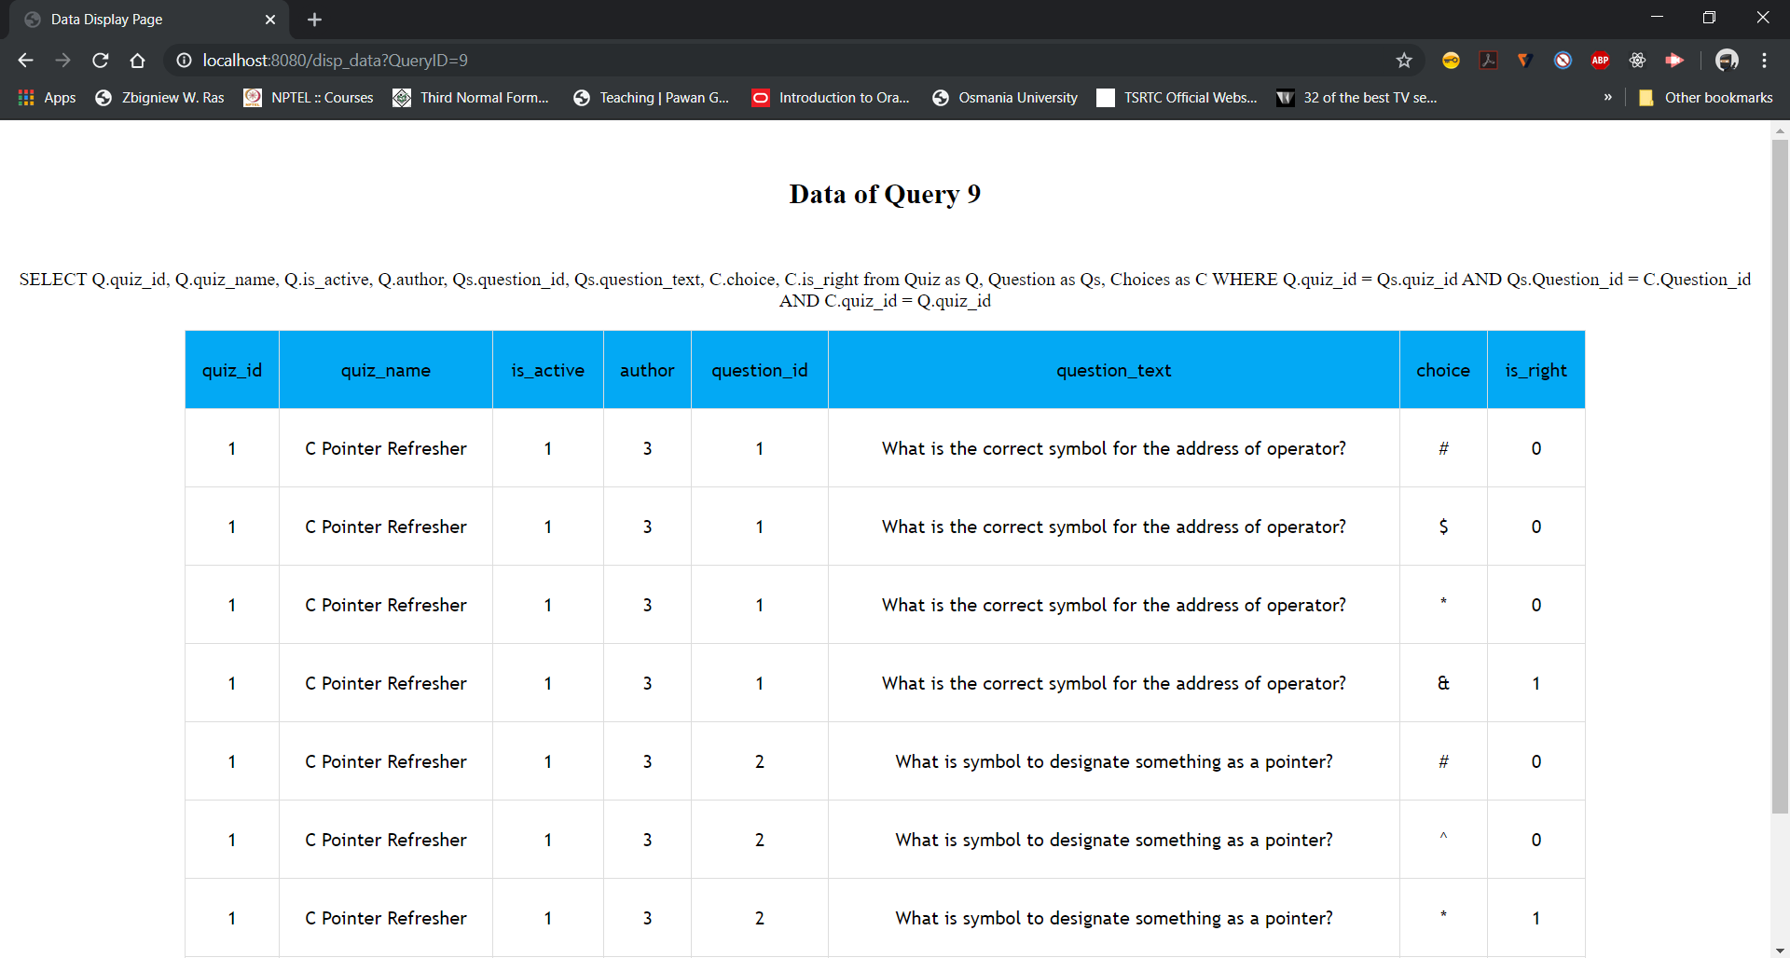

User story-4:

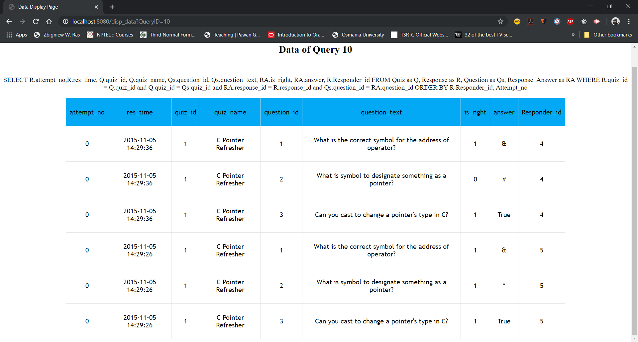

User story-5:

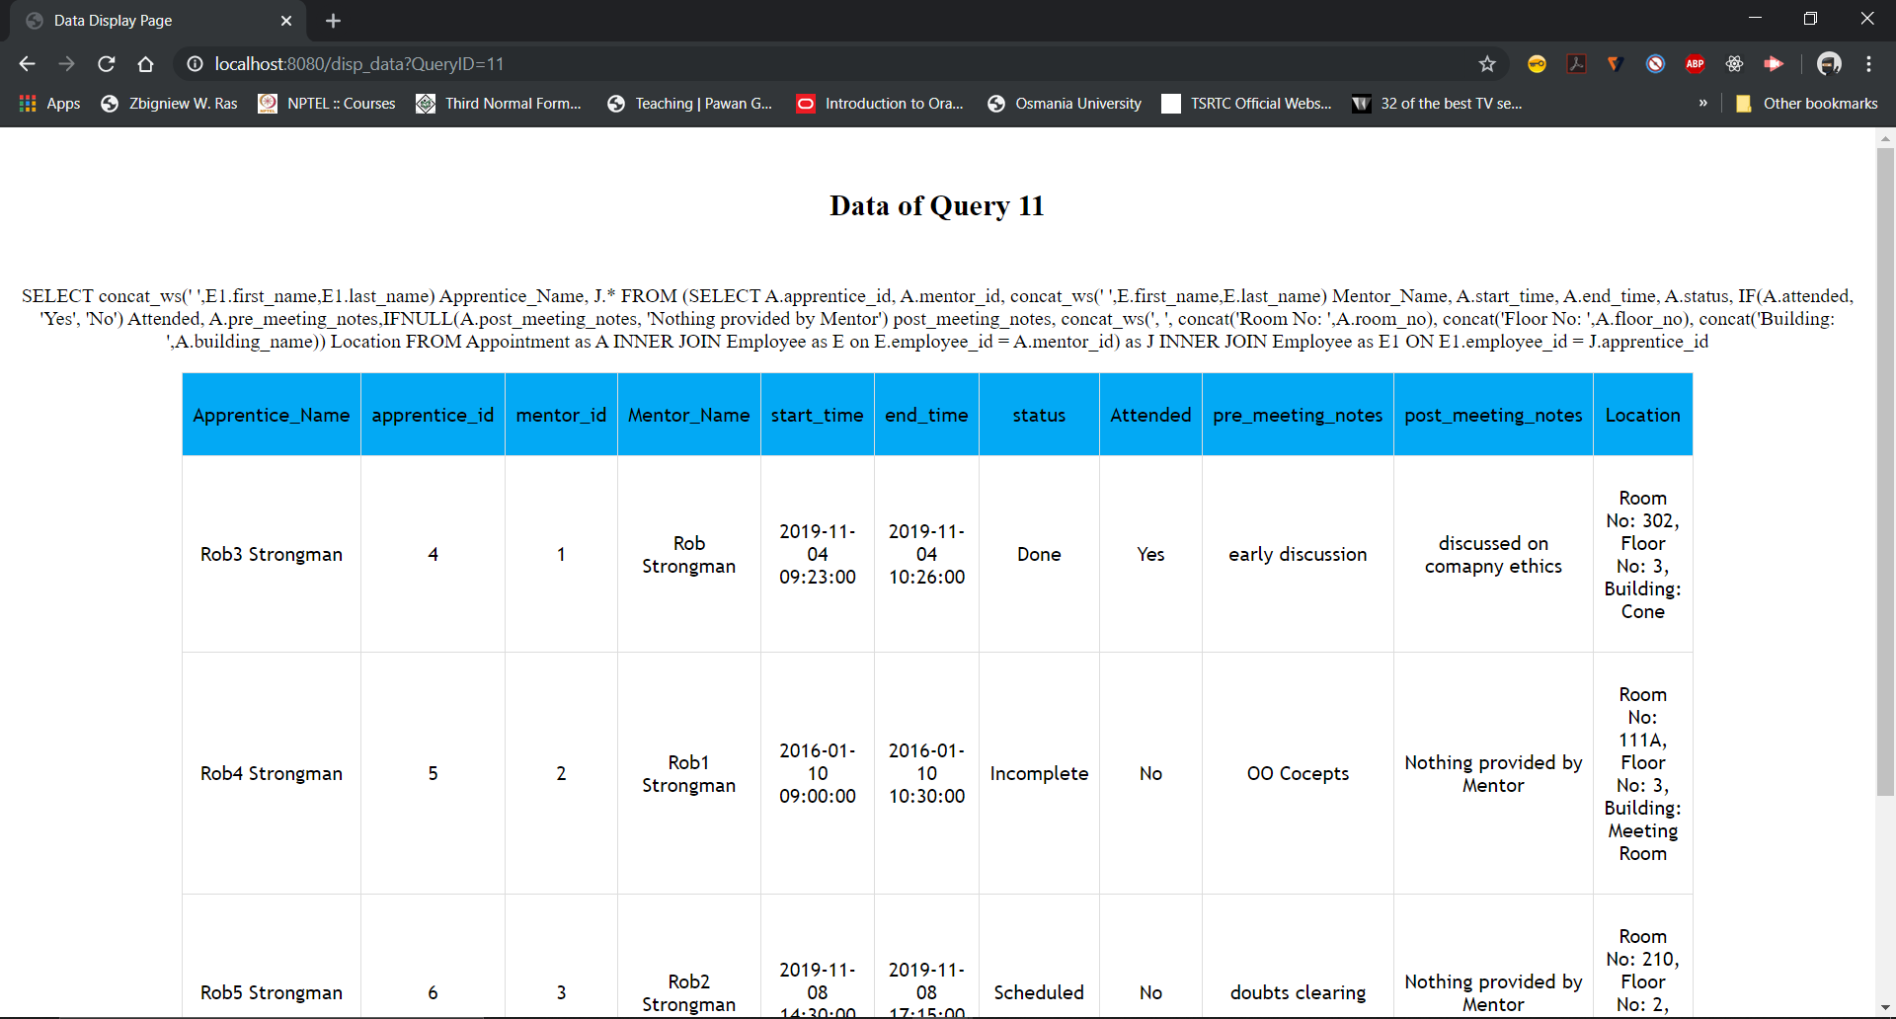

Combination of User story 4 & 5

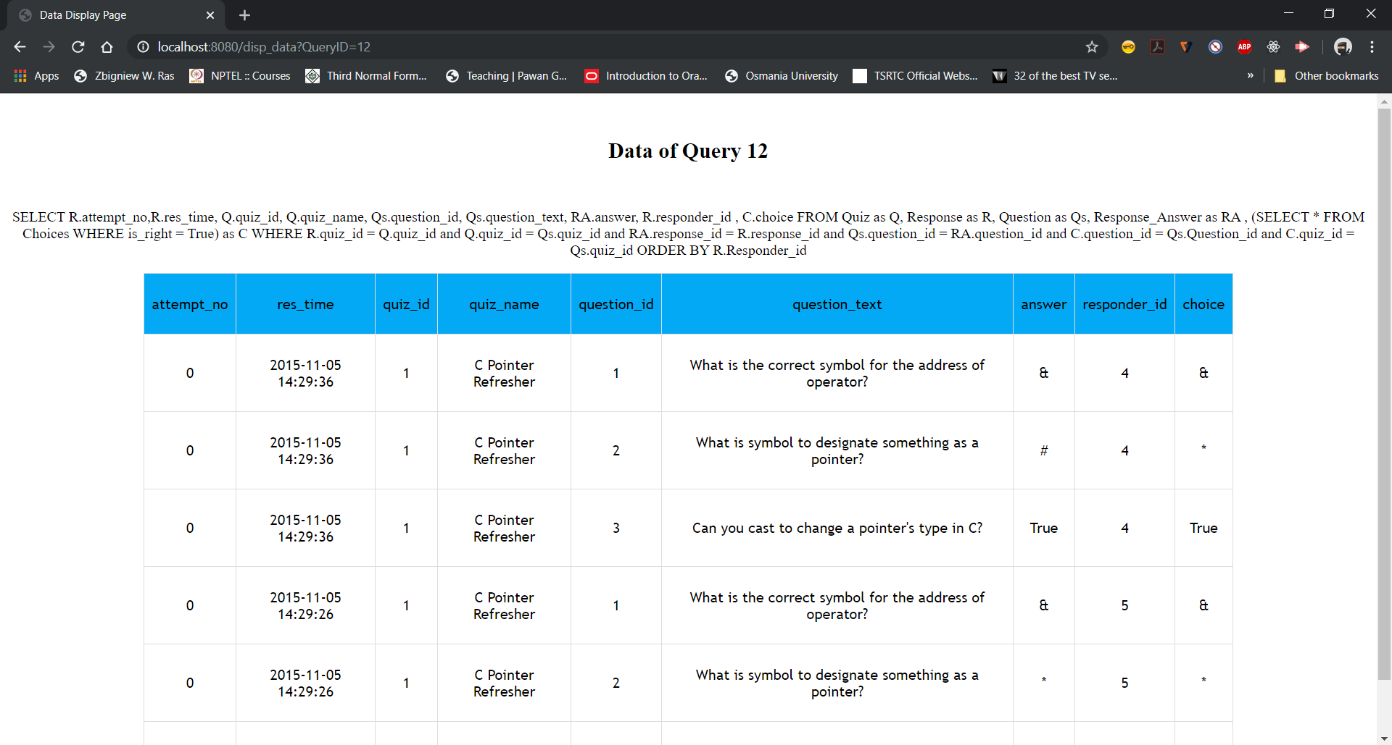

**SPRINT - 3**

**User Stories for Sprint 3:**

|  |  |
| --- | --- |
| **Story ID** | **Story description** |
| 7 | As a mentor, I want to post/update new homework so that apprentice can prepare for the quiz. |
| 8 | As an apprentice, I want to access homework assignments so that i can prepare for the quiz. |
| 9 | As a mentor, I want to file a weekly report on the apprentices so that I can track their progress. |

**CONCEPTUAL DESIGN:**

**Entities:**

Homework

**Attributes**:

Homework_Id

Announcement_time

Mentor_Id

Apprentice_Id

Is_Active

Is_Completed

Resources [multi-valued, composite]

Resource_Id

Resource_text

**Justification for Primary Key**: Because we want to reserve the option for a mentor to post homework to the same apprentice multiple times, we have decided to use a unique Homework_Id field to capture each unique homework assignment.

**Notes**: “Is_Active” is to say whether homework is active or not. “Is_Completed” is to say whether Apprentice completed homework by clicking “Mark as Done” in website.

WeeklyReport

**Attributes**:

Report_Id

Report_Time

Mentor_Id

Apprentice_Id

Score

Description

**Justification for primary key**: Because a given mentor-apprentice relationship will have multiple WeeklyReports, we have decided to have a unique Report_Id to uniquely identify reports. We have decided not to use a combination of apprentice_Id, mentor_Id, and Report_Time as a Primary Key because of the possibility of a mentor submitting multiple reports for the same apprentice at the same time. While unlikely, it is theoretically possible.

Quiz:

**Attributes**:

Quiz_Id

Quiz_Name

Quiz_PostedOn

Is_Active

Author

Questions[multi-valued, composite]

Question_text

Question_Id

Choice[multi-valued, composite]

Choice

Is_Right

Response [multi-valued, composite]

Response_Id

Res_Time

Attempt_No

Responder_Id [foreign key apprentice_id from apprentice]

Response_Answer[multi-valued, composite]

Answer_Id

Answer

Is_Right

**Justification for modification**: We need Quiz entity to have the Quiz_PostedOn attribute to capture time so that we can use it while generating weekly reports for Apprentices.

**RELATIONSHIPS:**

Mentor posts/updates Homework

**Cardinality**: one to Many

**Participation**: Mentor has partial participation

Homework has total participation

Apprentice views Homework

**Cardinality**: one to Many

**Participation**: Apprentice has partial participation

Homework has total participation

Mentor submits WeeklyReport

**Cardinality**: One to Many

**Participation**: Mentor has partial participation

WeeklyReport has total participation

**LOGICAL DESIGN:**

Tables:

Homework

**Columns**:

Homework_Id

Announcement_time

Mentor_Id [foreign key; references Mentor_Id in Mentor]

Apprentice_Id [foreign key; references Apprentice_Id in Apprentice]

Is_Active

Is_Completed

Resources

**Columns**:

Resource_Id

Homework_Id [foreign key; references Homework_Id in Homework]

Resource_text

WeeklyReport

**Columns**:

Report_Id

Report_Time

Mentor_Id [foreign key; references Apprentice_Id in Apprentice]

Apprentice_Id [foreign key; references Apprentice_Id in Apprentice]

Score

Description

Quiz

**Columns**:

Quiz_Id

Quiz_Name

Is_Active

Quiz_PostedOn

Author [foreign key; references Mentor_Id in Mentor]

Justification for Change: We need datetime of quiz to be captured so that it can be used in generating weekly report on Apprentice which will be used by Mentor to file a weekly report (For example, Mentor gives rating and feedback on how he performed in that week).

Question

**Columns**:

Question_Id

Question_text

Quiz_Id [foreign key; references Quiz_Id in Quiz]

Choices

**Columns**:

Choice

Question_Id[foreign key; references Question_Id from Question]

Quiz_Id [foreign key; references Quiz_Id in Quiz]

Is_Right

Response

**Columns**:

Attempt_No

Quiz_Id [foreign key; references Quiz_Id in Quiz]

Responder_Id [foreign key; references Apprentice_Id from Apprentice]

Res_time

Response_Id

Response_Answer

**Columns**:

Answer_id

Answer

Is_Right

Question_Id [foreign key; references Question_Id from Question]

Response_Id [foreign key; references Response_Id in Response]

**NORMALIZATION:**

Homework

**Normalized form**: 4NF

Resources

**Normalized form**: 4NF

WeeklyReport

**Normalized form:** 3NF

Justification: Because we have transitive dependency other than primary key. Non-key attributes are also functionally dependent on [Mentor_Id, Apprentice_Id, Report_Time] candidate key.

**INDEXES:**

Table: **Address**

**Index Name**: Address_empid_index

**Type**: Non-clustered

**Column order forming index**: employeee_id

**Justification**: In most of the queries we’re running we’re using only the employee_id column in the Address table, so we created an index for that only.

Table: **Administrator**

**Index Name**: Admin_id_index

**Type**: Clustered

**Column order forming index**: admin_id

**Justification**: In most of the queries we’re running, we’re using only the admin_id column in Administrator table, so we created an index on that only.

Table: **Appointment**

**Index Name**: Appointment_id_index

**Type**: Non-clustered

**Column order forming index**: mentor_id, apprentice_id

**Justification**: In most of the queries we’re running, we’ll be using mentor_id, apprentice_id columns to join with other tables hence we created an index on them.

Table: **Apprentice**

**Index Name**: Apprentice_Mentor_id_index

**Type**: Non-clustered

**Column order forming index**: mentor_id, apprentice_id

**Justification**: In most of the queries we’re running, we’ll be using mentor_id, apprentice_id columns to join with other tables hence we created an index on them.

**Type**:Clustered

**Column order forming index**: apprentice_id

**Justification**: In some of the queries we’re running, we’ll be using apprentice_id column to join with other tables hence created an index on them.

Table: **Choices**

**Index Name**: Apprentice_id_index

**Type**: Non-clustered

**Column order forming index**: quiz_id, question_id

**Justification**: In most of the join queries we’re running, we’ll be using quiz_id, question_id columns to join with other tables hence we created an index on them.

Table: **Employee**

**Index Name**: employee_username_index

**Type**: Non-clustered

**Column order forming index**: username

**Justification**: Need this index while checking user login credentials hence we created it.

**Index Name**: employee_id_index

**Type**:Clustered

**Column order forming index**: employee_id

**Justification**: Need this index while doing join with mentor, apprentice, admin tables to get their employee info.

**Index Name**: employee_name_index

**Type**:Non-Clustered

**Column order forming index**: first_name, last_name

**Justification**: Need this index while generating report or to search for employees with name fields.

**Index Name**: employee_title_date_index

**Type**:Clustered

**Column order forming index**: job_title, join_date

**Justification**: Need this index while generating report or to search for employees with their title or join date.

Table: **Homework**

**Index Name**: homework_emp_id_index

**Type**: Non-clustered

**Column order forming index**: apprentice_id, mentor_id

**Justification**: In most of the queries we’re running we’re using only the apprentice_id, mentor_id column in the Homework table, so we created an index on them.

Table: **Mentor**

**Index Name**: mentor_id_index

**Type**: Clustered

**Column order forming index**: mentor_id

**Justification**: In most of the queries we’re running we’re using only the mentor_id column in the Mentor table, so we created an index on them.

Table: **Message**

**Index Name**: message_id_index

**Type**: Non-clustered

**Column order forming index**: sender_id, receiver_id

**Justification**: In most of the queries we’re running we’ll be using sender_id, receiver_id columns in the Message table, so we created an index on them.

Table: **Question**

**Index Name**: question_quiz_id_index

**Type**: Non-clustered  
**Column order forming index**: quiz_id, question_id

**Justification**: In most of the queries we’re running we’ll be using question_id, quiz_id columns in the Question table, so we created an index on them.

Table: **Quiz**

**Index Name**: quiz_name_index

**Type**: Non-Clustered

**Column order forming index**: quiz_name

**Justification**: we need this so that mentor can search for quizzes with name field.

**Index Name**: quiz_id_index

**Type**: Clustered

**Column order forming index**: quiz_id

**Justification**: In most of the queries we’re running we’ll be using quiz_id column in the Quiz table, so we created an index on it.

**Index Name**: quiz_eid_index

**Type**: Non-clustered

**Column order forming index**: author_id, quiz_id

**Justification**: This index will be used when there is join on author and quiz_id with other tables.

Table: **Resources**

**Index Name**: resources_hwid_index

**Type**: Non-clustered

**Column order forming index**: homework_id

**Justification**: In most of the queries we’re running we’ll be using homework_id column in the Resources table, so we created an index on them.

Table: **Response**

**Index Name**: response_id_index

**Type**: Non-clustered

**Column order forming index**: responder_id, quiz_id

**Justification**: In most of the queries we’re running we’ll be using responder_id, quiz_id columns in the Response table, so we created an index on them.

Table: **Response_Answer**

**Index Name**: res_ans_id_index

**Type**: Non-clustered

**Column order forming index**: response_id, question_id

**Justification**: In most of the queries we’re running we’ll be using response_id, question_id columns in the Response_Answer table, so we created an index on them.

Table: **Weekly_Report**

**Indexes**: week_report_id_index

**Type**: Non-clustered

**Column order forming index**: mentor_id, apprentice_id

**Justification**: In most of the queries we’re running we’ll be using mentor_id, apprentice_id columns in the Weekly_Report table, so we created an index on them.

**STORED PROCEDURES & VIEWS:**

**VIEWS:**

**View**: EMPLOYEE_INFO

**Goal**: View consists of basic details of all employees like their id, username, full name, job title, hire date and their address details. It should be accessible to all database users as it consists of basic details about any employee and they cannot update or insert records using this view.

**View**: MENTOR_PUPILS

**Goal**: View consists of id’s and names of apprentice and their mentors. Using this view we can find if given apprentice is assigned to any mentor or not. It should be accessible only to Administrator and he’ll be creating relationships and needs this info to do his work.

**View**: APPRENTICE_INFO

**Goal**: View shows the data about apprentice respective info which can be used by management/admin.

**View**: MENTOR_INFO

**Goal**: View shows the data about meetings respective info which can be used by management/admin.

**View**: ADMIN_INFO

**Goal**: View shows the data about meetings respective info which can be used by management/admin.

**View**: ALL_HOMEWORKS

**Goal**: View shows the Homeworks posted and their status respective with publishing and completion status by student.

**View:** ALL_REPORTS

**Goal**: View shows all the reports along with names of employees involved, score and description. This can be used to see the performance of apprentices.

**TRIGGERS:**

**Trigger**: `MMS_Sprint3`.`Appointment_BEFORE_UPDATE` BEFORE UPDATE ON `Appointment`

**Goal**: This trigger changes the status of attended to true when status of the meeting is marked as done. Update should be done by Mentor as he’ll be using view ``

**Trigger**: `MMS_Sprint3`.`Appointment_BEFORE_INSERT` BEFORE INSERT ON `Appointment`

**Goal**: This trigger insert a row with proper status and attended value before inserting,even though wrong values were given in status and attended while inserting.

**PROCEDURES:**

**Stored procedure**: MAKING_LOGINS_INACTIVE

**Goal**: This stored procedure captures all(mentor, apprentice, administrator) accounts or their employee ids where mentor, apprentice & administrator didn’t login for last 90 days.

**Example**: CALL MAKING_LOGINS_INACTIVE();

**Stored procedure:** GET_QUIZ

**Goal**: This stored procedure allows application to get quiz related data like questions and answer choices concatenated when quiz_id and is_active values are provided.  
**Example**: CALL GET_QUIZ(1,1);

**Stored procedure:** LOGIN_TIME_UPDATE

**Goal**: This stored procedure allows application to update login time depending on the id and table code we’ve provided during the call.

**Example**: CALL LOGIN_TIME_UPDATE(1,'M');

**Stored procedure:** LOGOUT_TIME_UPDATE

**Goal**: This stored procedure allows application to update logout time depending on the id and table code we’ve provided during the call.

**Example**:CALL LOGOUT_TIME_UPDATE(1,'M');

**Stored function**: SCORE_CALCULATION

**Goal**: This stored function takes quiz_id, responder_id, attempt_no as input and returns a decimal value(5,3) which is percentage apprentice accumulated in given attempt and quiz.

**Example:**

SELECT SCORE_CALCULATION(1, 5, 0) AS Score;

SELECT SCORE_CALCULATION(1, 4, 0) AS Score;

**IMPLEMENT & DEPLOY DATABASE:**

Database Name: MMS_Sprint3

**Sprint3 - Key SQL Queries for Demonstration**

**Queries:**

Views

-------------------------

SELECT * FROM EMPLOYEE_INFO;

SELECT * FROM MENTOR_PUPILS;

SELECT * FROM APPRENTICE_INFO;

SELECT * FROM MENTOR_INFO;

SELECT * FROM ADMIN_INFO;

SELECT * FROM ALL_HOMEWORKS;

SELECT * FROM ALL_REPORTS;

StoredProcedures

----------------------------

CALL MAKING_LOGINS_INACTIVE();

CALL GET_QUIZ(1,1);

CALL LOGOUT_TIME_UPDATE(1,'M');

CALL LOGIN_TIME_UPDATE(1,'M');

Function

-----------------------

SELECT SCORE_CALCULATION(1, 5, 0) AS Score;

SELECT SCORE_CALCULATION(1, 4, 0) AS Score;

**Demonstration:**

HomePage:

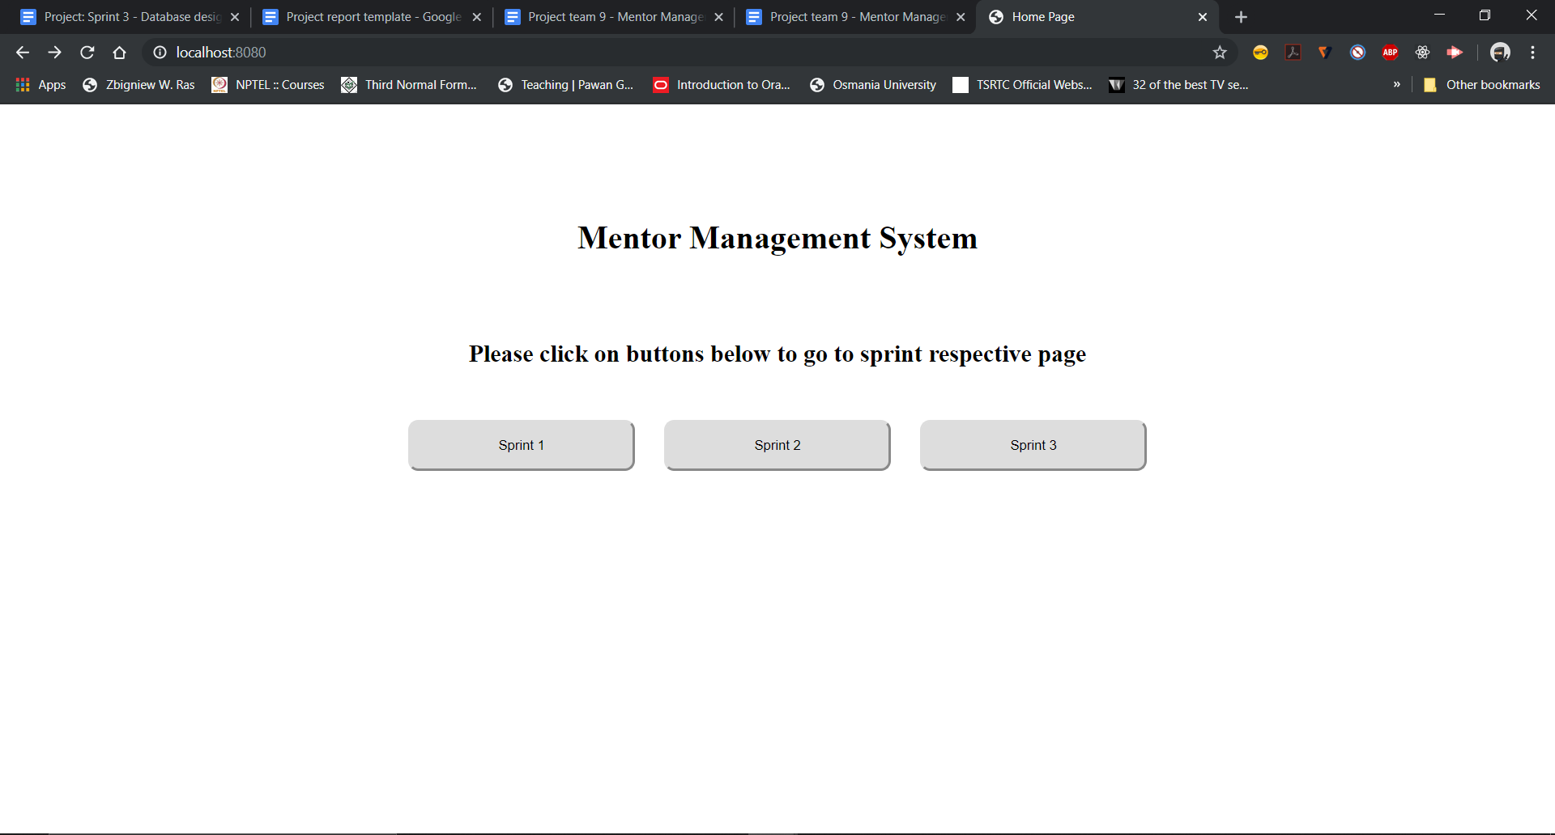

Sprint3 Page:

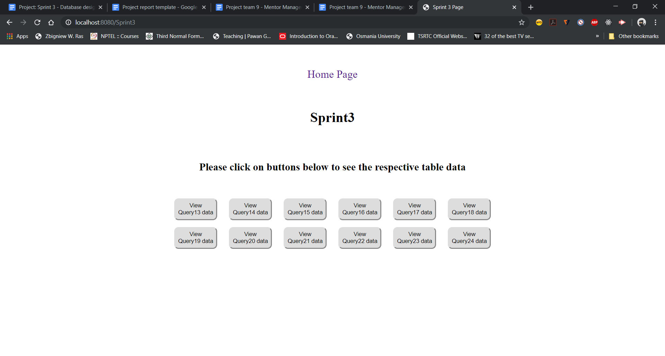

Query-13:

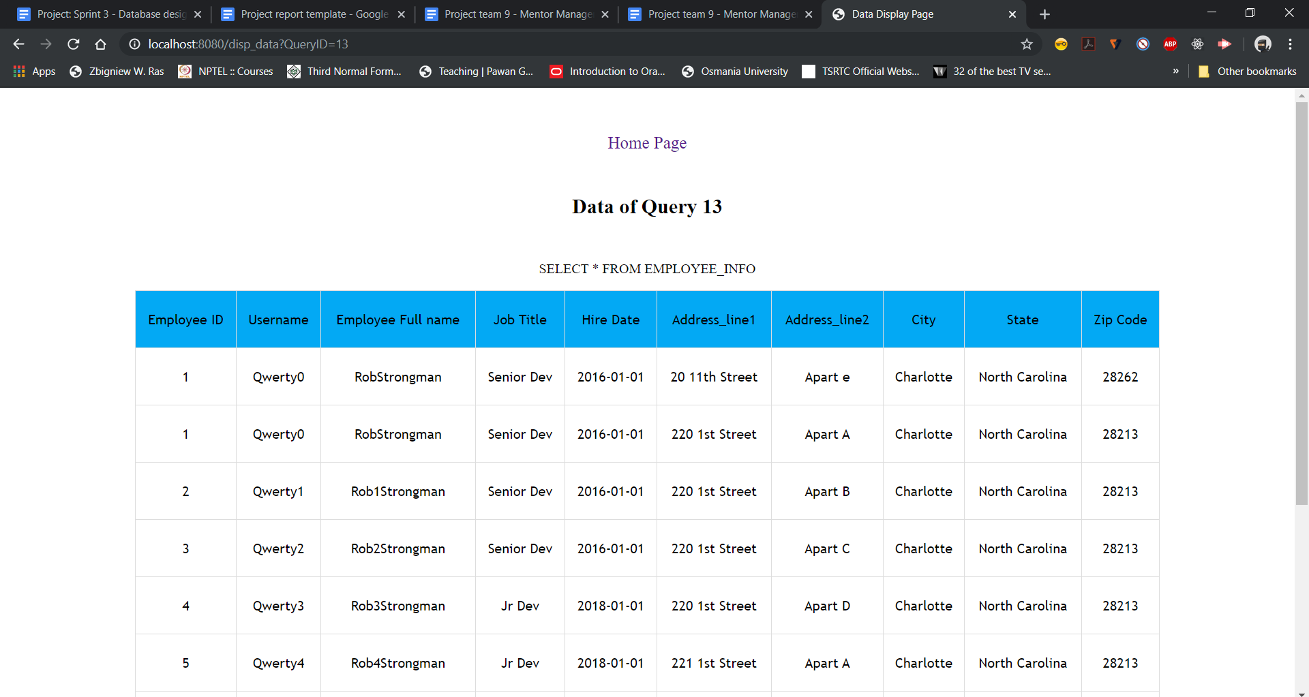

Query-14:

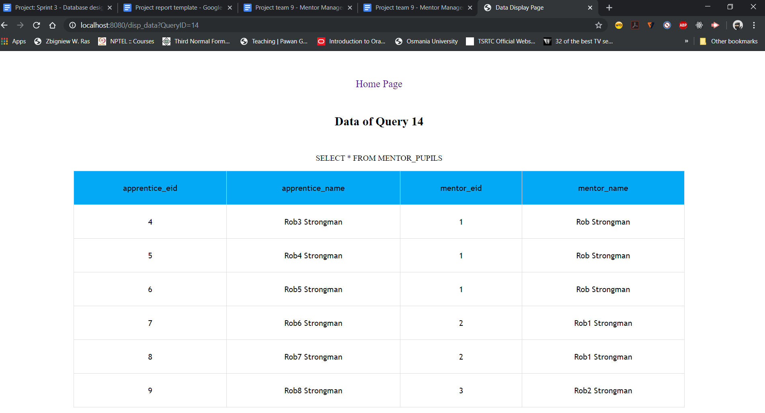

Query-15: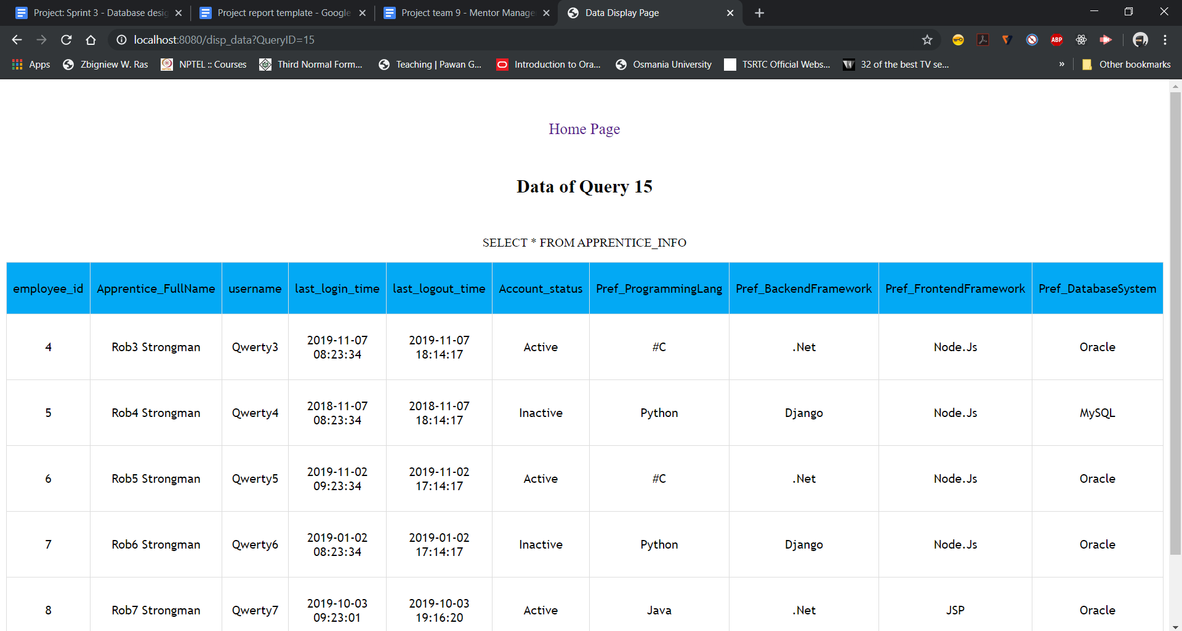

Query-16:

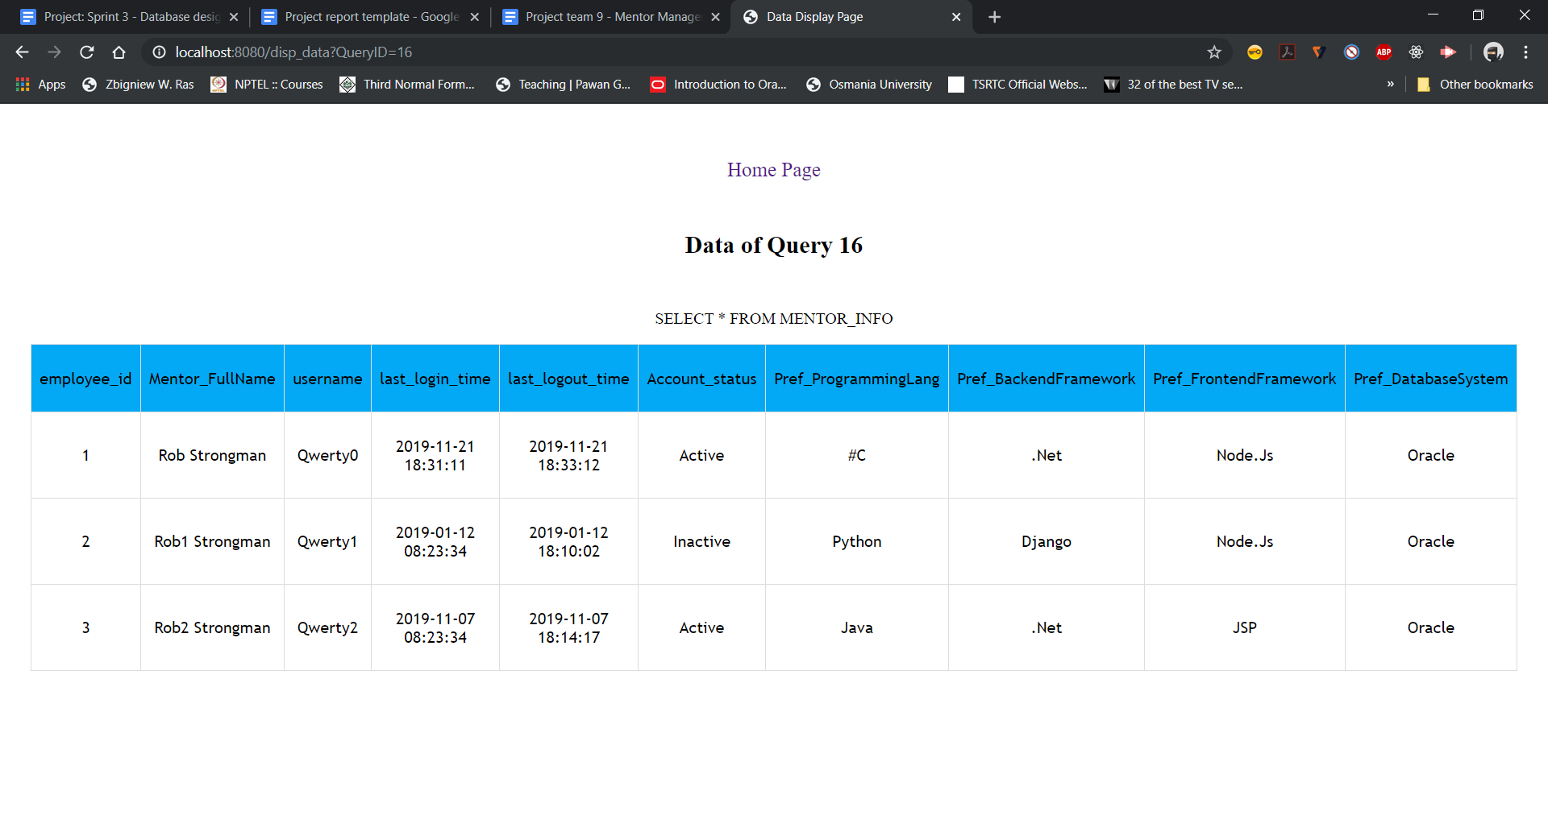

Query-17:

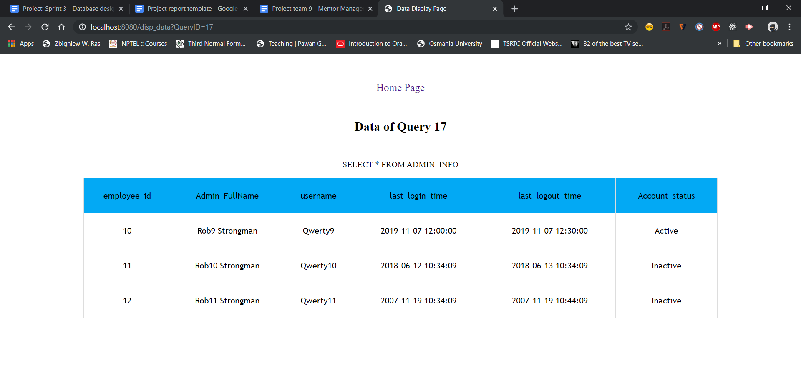

Query-18:

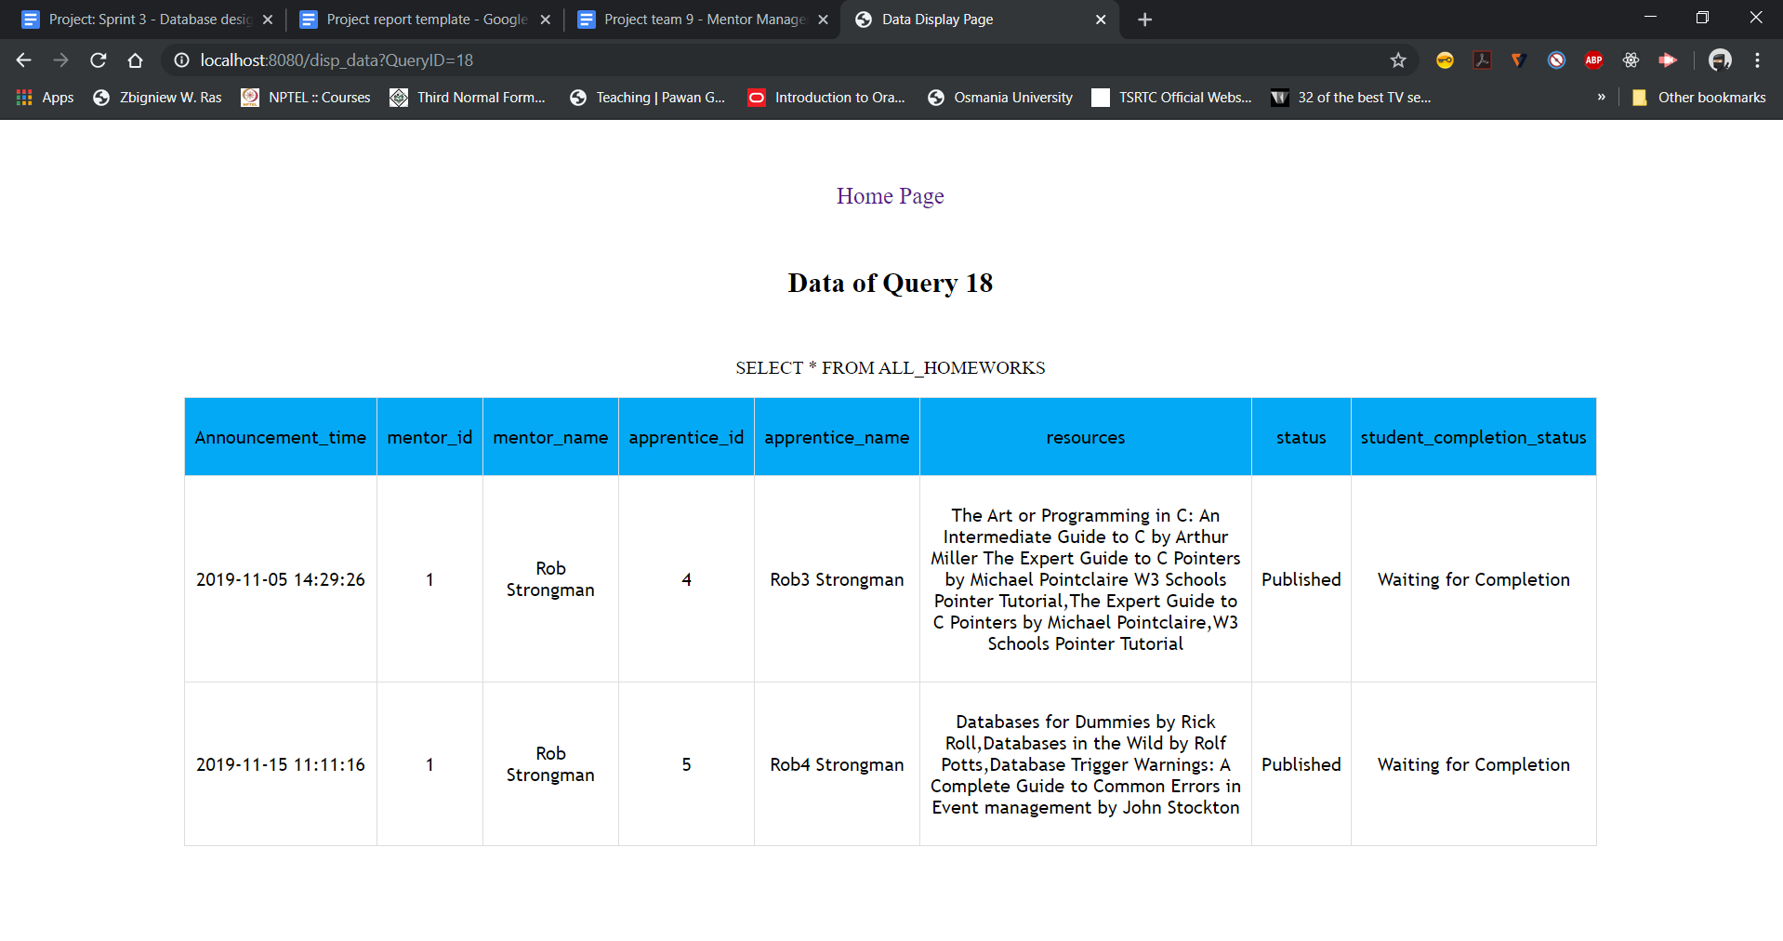

Query-19:

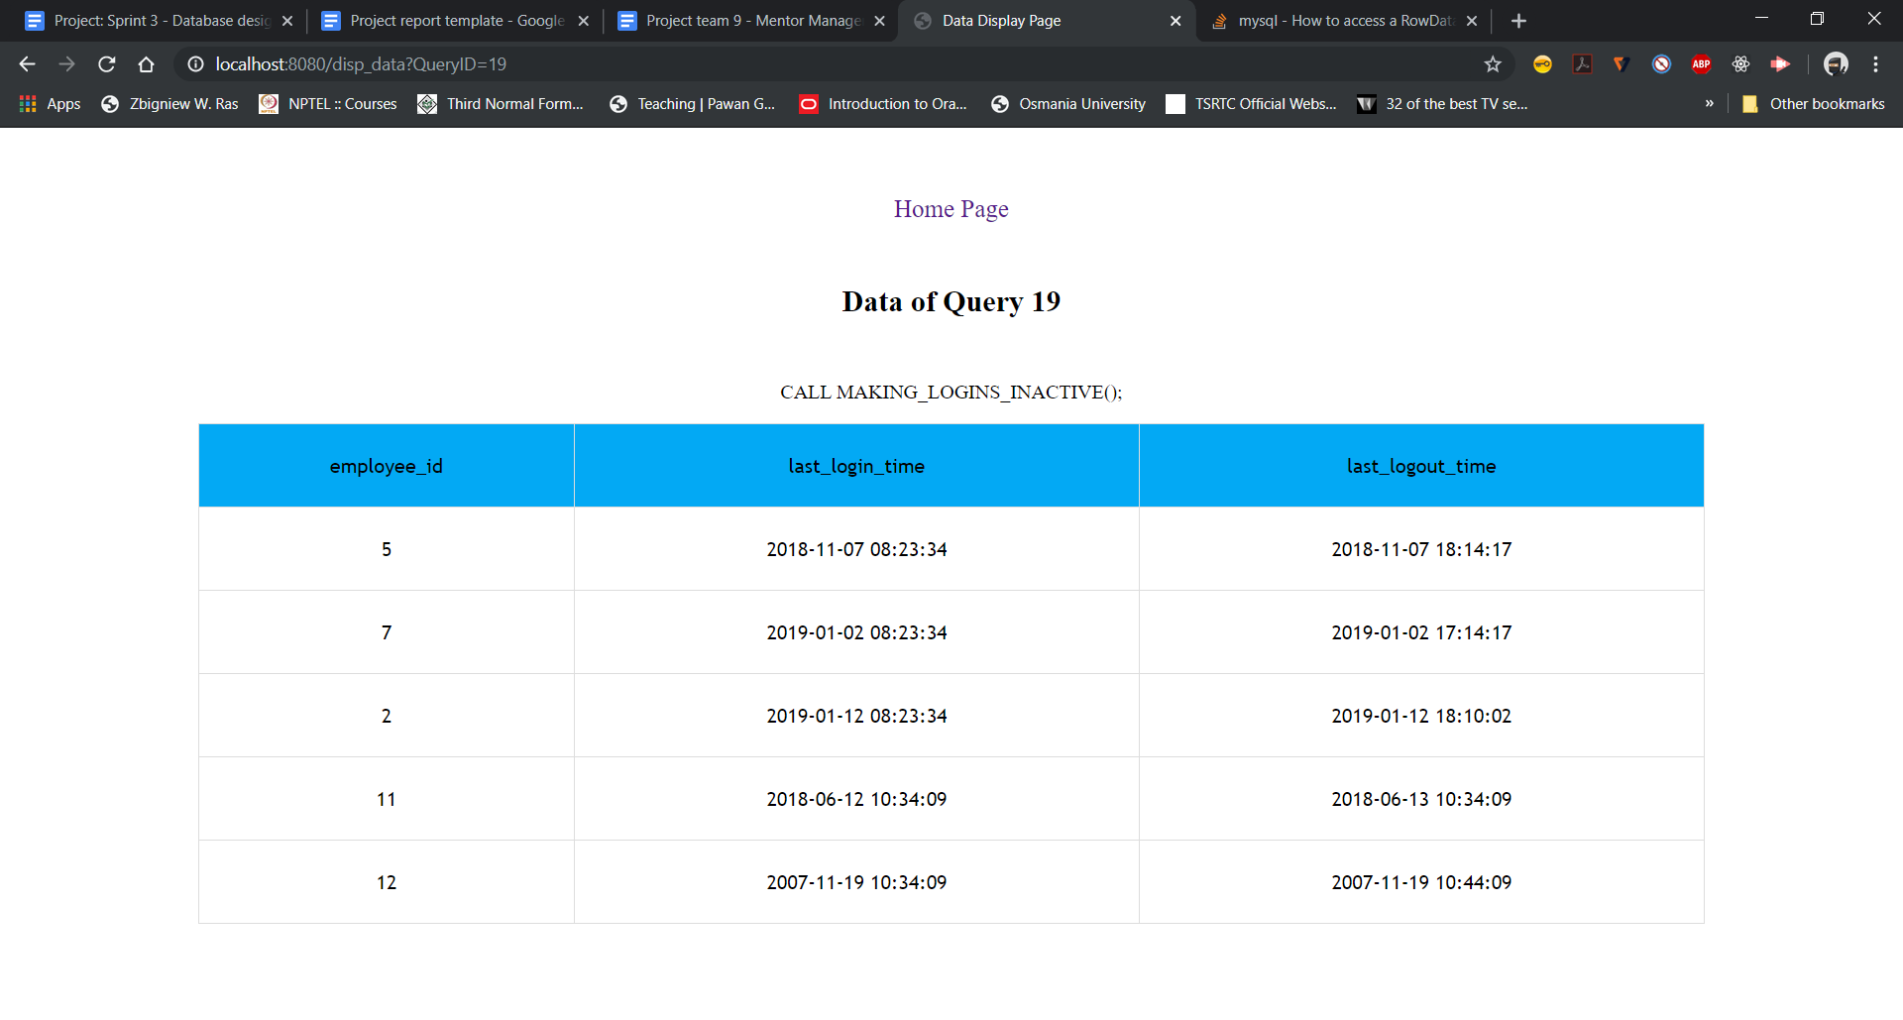

Query-20:

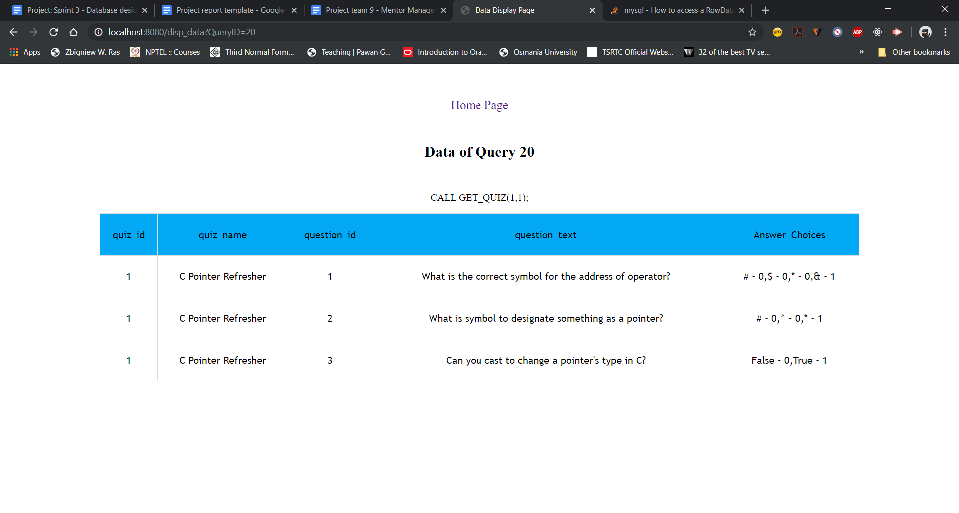

Query-21:

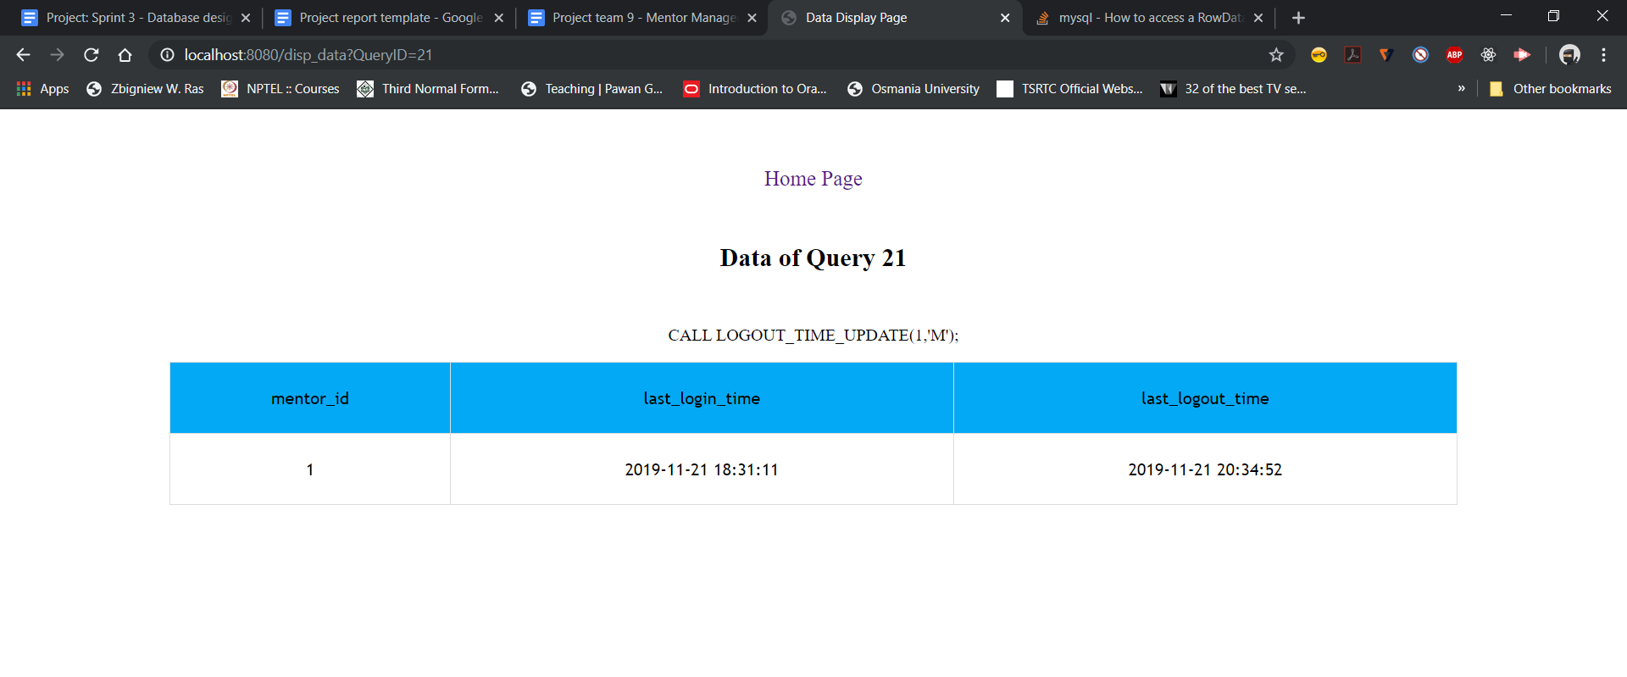

Query - 22:

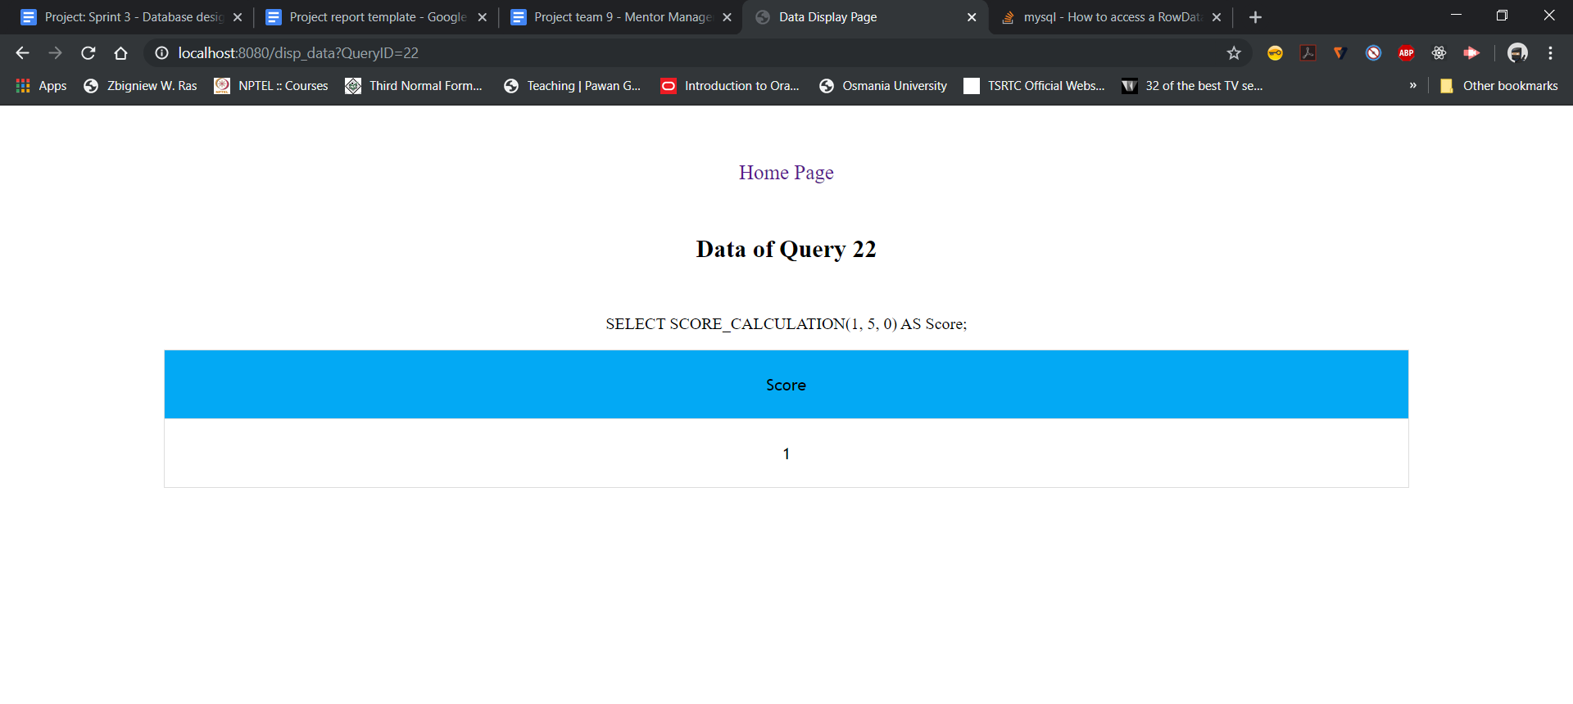

Query-23:

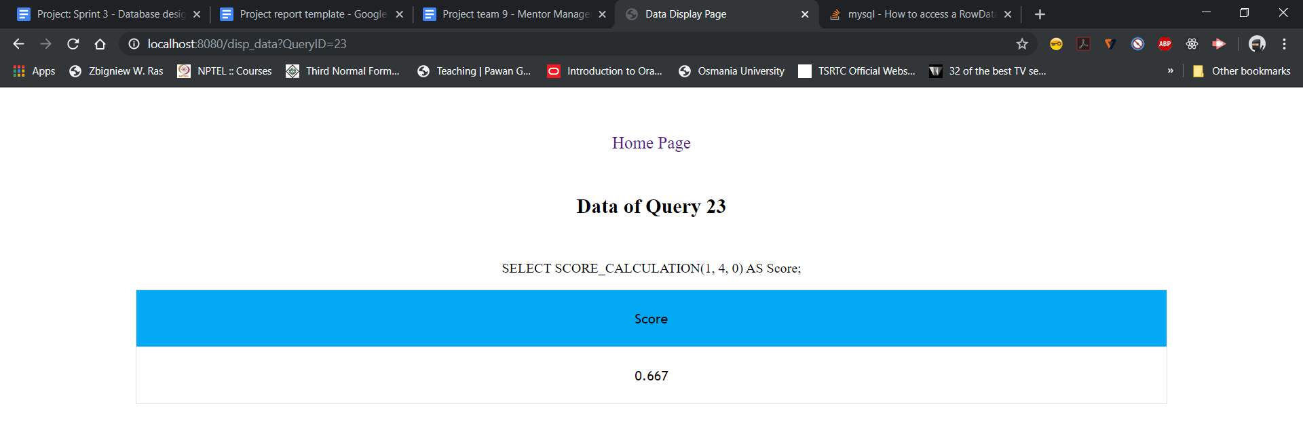

Query-24:

